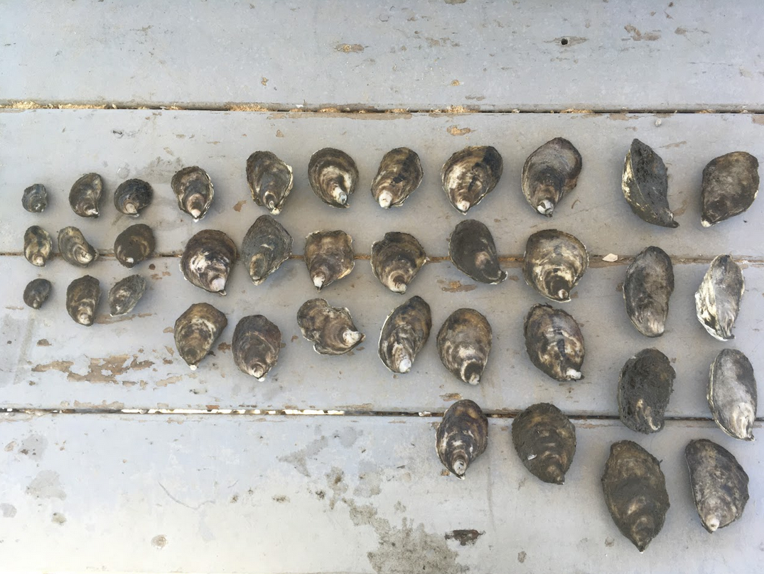

**Position Available: Paid Summer Undergraduate Research Assistant**

**Position Title:** Research Assistant **Application Deadline:** By 11:59pm on May 22, 2025

**Description:**

Are you an undergraduate interested in working on applied research and gaining lab experience? Janine Barr (Rutgers Oceanography M.S. 2019-2022, Rutgers Bloustein Senior Research Specialist 2023-current) is looking for a motivated undergraduate to assist in an exciting summer project focusing on oyster (*Crassostrea virginica)* ecosystem services. The purpose of this project is to quantify the water quality benefits aquaculture oysters provide along the New Jersey and Delaware coasts today as well as under future climatic conditions (*i.e.,* increased rainfall). Water quality benefits for this research are measured using an Elemental Analyzer (*i.e.,* a piece of lab equipment used to determine the amount of nitrogen in oyster samples). This data will be used to generate the Oyster Eco-Serve Calculator 2.0 (the first edition is available at [go.rutgers.edu/ru.oyster.calculator](https://itsappserver.sebs.rutgers.edu/Oysterecoservecalc/)). This calculator estimates the annual, seasonal, and daily farm-level water quality benefits provided by oysters in the Mid-Atlantic. The updated calculator will be (1) an education tool paired with outreach materials to help inform the public about the environmental benefits provided by aquaculture oysters and (2) a data rich tool that could be used by farmers to build social capital and interest in their harvested oysters to help expand their businesses.

The key duties of this position include:

* Processing samples through an Elemental Analyzer (training on how to use this equipment will be provided).
* Data entry and organization.
* As well as other relevant work opportunities based on the interests and career goals of the selected student.

This job opening is funded by the New Jersey Sea Grant Consortium and includes collaborators at the Rutgers Haskin Shellfish Research Lab, Rutgers Bloustein School of Planning and Public Policy, and more. **This position is also eligible for Experiential Learning Credits.**

**Qualifications:**

* Applicants must ***currently (April 2025) be a freshman, sophomore, or junior undergraduate student*** majoring in a science or technical field (*e.g.,* marine science, environmental science, geology, other physical sciences).
* Good organizational skills, knowledge of Microsoft Excel, ability to fill out detailed datasheets.
* No past lab or field experience is required.

**Logistics:**

* **State Date:** Flexible start date (approximately June 23, 2025) with the opportunity to extend into the Fall Semester. Student will be hired to work no more than 40 hours over a period of three months. All samples must be processed by October 31, 2025.
* **Location:** DMCS (71 Dudley Rd, New Brunswick, NJ 08901)
* **Salary:** Hourly wage of $15.00/hour.

**How to Apply:**

* Email a **resume, cover letter**, and **contact information for one reference** to Janine Barr at [janine.barr@rutgers.edu](mailto:janine.barr@rutgers.edu). All questions can be sent to Janine Barr at [janine.barr@rutgers.edu](mailto:janine.barr@rutgers.edu).
* Resumes should be no more than two pages and include your academic history and relevant work experiences.
* Cover letters should address (1) any relevant special skills or experience that you have and (2) the educational and professional goals you expect to achieve as a result of this position.
* Please also include only the name, position title, email address, and phone number of one professional reference. This information can be included in the body of the email you send. A reference letter is not required. We will contact references of shortlisted candidates.