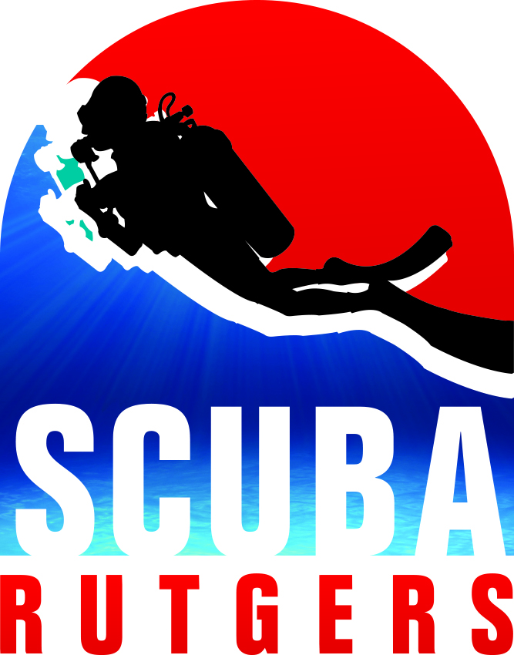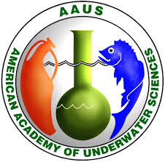
SCIENTIFIC DIVING CERTIFICATION

Scientific Diving II (course #11:628:346 ) is the second experiential academic 3 credit course for the AAUS Scientific Diver Certification designed to provide the student with the academic, practical, and SCUBA skills training to meet and exceed the American Academy of Underwater Science’s (AAUS) minimum standards for Scientific Diving certification. The course provides the student with training in dive safety, diving emergency procedures, oxygen administration, neurological assessment, first aid for hazardous marine injuries, mixed gas (Nitrox) and technical diving methodology, dive planning and the application of science diving techniques. These core elements will cover the advanced academic and practical skills application in both confined water (pool) and open water environments. Training materials developed by the AAUS, PADI & DAN will be used for the academic component of the program.
Students will be required to demonstrate proficiency in both their knowledge of course materials with quizzes, exams, in-water safety, and emergency procedures, as well as scientific diving methods. In addition, the student will be required to work on a group project related to a marine research issue. The project will involve study/search of current research projects/papers on the issue topic, planning, assembling and implementing the project as part of an ongoing research project. Project will be a practical application that expands on course subject matter, dive equipment, diving modes, or science diving methods and techniques.
Pre-requisite Requirements: Scientific Diving I Course 11:628:345. Students who have not taken the Scientific Diving I course may be granted admission if they have a minimum SCUBA diving certification level of “Rescue Diver” or its equivalent from a nationally/international recognized dive certification agency and arrange through independent study to complete AAUS topics & skills from 11:628:345. Additionally, medical clearance for scuba diving is a prerequisite requirement prior to in-water training. Individuals interested in receiving the AAUS Scientific Diving Certification will be required to complete a medical evaluation in accordance with the AAUS Standards and the Rutgers Scientific Diving Program prior to certification.
Students successfully completing individual training components of the program will receive certification with the Professionally Association of Underwater Instructors (PADI) - PADI Enriched Air Specialty, & PADI Deep Diver Specialty & PADI Underwater Navigator Specialty; and Divers Alert Network (DAN) – Diving First Aid for Professional Divers (DFAPro) certification. An AAUS Science Diver-in-Training Certification will be issued to those students meeting all the requirements of the AAUS training program. All AAUS Certification requirements must be completed within 6 months after course completion.

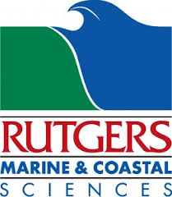
70 Dudley Rd •New Brunswick, NJ 08901 •scuba@marine.rutgers.edu •848-445-1337
SCIENTIFIC DIVING CERTIFICATION
Scientific Diving I (course #11:628:345 ) is a 3 academic credit introductory course designed to provide the student with the academics, practical skill applications, and SCUBA diving training to become competent and confident divers. Training will be conducted under the minimum standards of both the American Academy of Underwater Sciences (AAUS) and applicable recreational training agencies towards achieving AAUS Scientific Diving certification. The course will provide the student with training in open water, advanced open water and rescue diver skills. Knowledge development and skills will include dive safety, Safe diving skills, diving physics, diving physiology, equipment care and maintenance, diving fitness, dive planning, oxygen administration, CPR/First Aid, scientific methods and an introduction to science diving. These core elements will cover the academic and practical skills application in a confined water (pool) environment. Training materials developed by the AAUS, PADI & DAN will be used for the academic components of the program.
Course Prerequisite – Students must be certified PADI Open Water Diver (or its equivalent from a nationally/international recognized dive certification agency), OR have completed Basic Scuba (course 11:628:230), OR completed the academics & confined water portion of the PADI Open Water Diver Course. Students who are not certified divers will complete the academics & confined water skill requirements for PADI Advanced Open Water Diver and Rescue Diver. Open water certification dives are not included in the course, the opportunity to complete open water dives for certifications will be offered June – October.
Certified divers will complete academics and confined water skill requirements for skill refreshers on current levels of certification and any additional level up to Rescue Diver. For divers certified at Rescue or above, divers can select 1 of the following PADI Specialties: Peak Performance Buoyancy, Oxygen Provider, or Underwater Naturalist.
Eligibility Requirements: Students need to complete a medical statement and if applicable, obtain written medical clearance for scuba diving as a prerequisite requirement prior to in-water training. Individuals interested in an AAUS Scientific Diving Certification will be required to complete a medical evaluation in accordance with the AAUS Standards and the Rutgers Scientific Diving Program prior to certification.
Students successfully completing each individual training component of the program will receive certification with the Professionally Association of Underwater Instructors (PADI) and Divers Alert Network (DAN). An AAUS Science Diver Certification will be issued to those students meeting all the requirements of the training program.
70 Dudley Rd •New Brunswick, NJ 08901 •scuba@marine.rutgers.edu •848-445-1337

