Response to Reviewers

Editor:

Specific concerns focus on (1) improved descriptions of the various numerical parameterizations and initialization procedures; (2) an additional simulation to clarify potential impacts of poor oceanic initialization in operational models, and (3) additional analyses/verification related to environmental relative humidity and vertical wind shear.

Reviewer #1:

Overall, this was a good paper with some significant scientific merit. I would suggest some major revisions to the text. These include minor changes to formatting, several references that should be reviewed and possibly added, a few questions that could use clarifying, along with a few areas of additional analysis I would like to see performed for a future draft. These are detailed below...
Line 68: Jim Price has numerical studies investigating the right-side SST cooling bias in the northern hemisphere, definitely worth including here as you did in Lines 105-106.
(Price 1981; Price et al. 1994)

Included Price (1981) and Price et al. (1994) in lines 68-69.
89: "over-forecast" is a strange term. Suggest avoiding it by rephrasing… "its intensity was over-predicted by hurricane models (i.e. "guidance") and in resultant National Hurricane Center (NHC) forecasts"

Changed wording to as suggested.
98-100: "The authors suggest that Irene absorbed the dust and aerosols, which, in combination with sea surface temperature (SST) cooling between the Bahamas and NC, led to the storm's rapid demise." 102: "presumably due to aerosol interaction" I am not familiar with this mechanism. Is there any previous literature to suggest this as a known mechanism in reducing storm strength/intensity? Do you have model comparisons that demonstrate this? I certainly agree that decrease in SST and a shallower mixed layer/OHC would weaken the storm. Can you isolate "aerosol interaction" in the model to determine contributions in weakening from aerosols vs SST?

Scott, Travis look at this

Lynn et al. (2015) provides details on the mechanisms by which TC intensity can both strengthen and weaken due to the aerosol indirect effect. Lynn et al. (2015) list several studies that show aerosol-induced convection invigoration tends to intensify tropical convection, and can thus foster initial TC development. However, aerosols can have the reverse effect of weakening a TC as it approaches land, due to the intensification of convection at the TC periphery due to the presence of continental aerosols. Lynn et al. (2015) and Khain et al. (2016) performed a sensitivity study to demonstrate the aerosol indirect effect on Irene as well as the impact of ocean cooling on Irene in the South Atlantic Bight (although they incorrectly use data from glider RU16 which was positioned in the Mid Atlantic Bight to initialize and validate 1D ocean simulations they perform using the WRF 1D OML model).

To isolate “aerosol interaction” in the model to determine contributions in weakening from aerosols vs. SST cooling in the Mid Atlantic Bight, we performed an additional simulation using mp_physics=30, which uses the ‘fast’ version of Hebrew University of Jerusalem, Israel (HUJI) spectral bin microphysics (using WRF V3.6.1). Wording on lines 244-245 now includes “[including a simulation with WRF spectral bin microphysics (Khain et al. 2010) to test sensitivity to aerosols]”. Table 1 was changed accordingly, and the results are now included in Figure 4, showing that sensitivity to SST is much greater than to “aerosol interaction”. Response to Reviewers (RR) Figures 1 and 2 include this additional aerosol sensitivity, showing a storm weaker throughout the whole simulation due to aerosol interaction, and showing larger sensitivity to aerosols early on in the simulation and smaller sensitivity to aerosols while Irene is over the Mid Atlantic Bight.

Due to the reviewer’s suggestions above, the wording in lines 97-106 was changed to (added Khain et al. 2016 reference in first sentence):

“One hypothesis as to why Irene unexpectedly weakened between the Bahamas and NC involves both aerosols and ocean cooling (Lynn et al. 2015; Khain et al. 2016). Irene crossed a wide band of Sahara dust just north of the West Indies, initially causing convection invigoration in the simulated eyewall and fostering the hurricane’s development (Lynn et al. 2015). However, as Irene approached the U.S., continental aerosols intensified convection at the simulated storm’s periphery. This intensification of convection at the TC periphery can lead to increases in TC central pressure and weakening of wind speed near the eyewall (Lynn et al. 2015 and references within).
This paper’s focus is on Irene’s time after its NC landfall (Fig. 1) and after it had weakened in intensity due to continental aerosol interaction with convection at the hurricane’s periphery and the very slight SST cooling in the South Atlantic Bight (SAB).”
130: "Glider RU16 was used in this study." RU = Rutgers University? Might be worth mentioning as a plug for your institution.

Changed to “Rutgers University Glider 16 (RU16).
131: Add commas in breaking down CTD… "unpumped conductivity temperature and depth (CTD) sensor" -> "unpumped conductivity, temperature, and depth (CTD) sensor"
Changed as suggested.
132-133: "The top bin in the temperature profiles is used to provide a measure of near-surface temperature at the glider location (Fig. 1)." What was the depth range of this bin? "Near-surface" can vary drastically vs SST from NDBC buoys vs satellite-derived skin temperature.
The depth range of this bin is 0-1m. Included this depth range in the manuscript.
133-134: "Thermal-lag induced errors associated with the unpumped CTD were corrected before any data were used." Any references for these corrections?

Added this reference for the thermal-lag correction:

Garau, B., Ruiz, S., Zhang, W. G., Pascual, A., Heslop, E., Kerfoot, J., & Tintoré, J. (2011). Thermal lag correction on Slocum CTD glider data. Journal of Atmospheric and Oceanic Technology, 28(9), 1065-1071.
154-156: "Finally, relative humidity (RH) measurements from the buoys at 4m may have larger uncertainty during Irene's high wind conditions due to sea spray". Any reference for this to actually quantify the uncertainty?

Included two new references here (Coantic and Priebe 1980; Breaker et al. 1998) which describe how salt spray accumulation can degrade humidity sensor calibration accuracy and is the major source of error, and how “humidity sensors must recover rapidly from periods of saturation without change to their calibration”.
178-181: "To validate profiles of modeled wind shear and dry air intrusion, radiosonde observations of u and v winds are used from Buffalo International Airport, NY (KBUF) and RH is used from Wallops Island, VA (KWAL)." What about KOKX? Seems like that would be a good choice as the closest impacted area. Are you looking further upstream/downstream? The outflow from Irene for stream calculations should be taken at distances off to the north and east as it was moving through the MAB as well (KOKX, KALB, KCHH). These stations all recorded obs at 12 and sometimes 6 hourly intervals. They may be relevant to your analysis of measuring shear and dry air intrusion and should be included.

Greg needs to do more in depth shear analysis
191: Include references for HWRF ((Skamarock et al. 2008)), POM ((Blumberg and Mellor 1987)), and HYCOM ((Chassignet et al. 2007)) development.

References included.
215: More recent reference for WRFv3+: (Skamarock et al. 2008)

Reference changed.
222-223: "WRF Double-Moment 6-class moisture microphysics scheme was used for grid-scale precipitation processes." Reference for this scheme? With 6-km grids, you're right in the danger zone of running tropical cyclone simulations while resolving only grid-scale precipitation processes. Was no cumulus parameterization used? (Molinari and Dudek 1992) has shown that explicitly resolving grid-scale precipitation at 4-7km scales without any cumulus parameterization could produce dubious results.
Lim and Hong (2010, MWR) was included as a reference for the WRF Double-Moment 6-class moisture microphysics scheme.

As Reviewer 1 notes below, sensitivity to cumulus parameterization was tested through a subsequent simulation. This is indicated in new wording on lines 231-232: “The control simulation did not include cumulus parameterization (Kain 2004); sensitivity to cumulus parameterization was tested in a subsequent simulation (see below and Table 1).”
226-229: "Several different lateral boundary conditions and initialization times were experimented with before arriving at the best solution. The resulting lateral boundary conditions used are from the Global Forecast System (GFS) 0.5° operational cycle initialized at 06 UTC on 27 August 2011." This is almost the identical technique used in a previous coupled modeling study (Zambon et al. 2014a), which should be referenced. I presume the resultant initial conditions were also used, not just the lateral boundary conditions -> "The resulting initial and lateral boundary conditions…"

Included Zambon et al. 2014a as a reference for this method, and included “initial” in line 237.
233: "18 UTC on 28 August" is not actually shown in Fig. 1.

Moved the Fig. 1 reference to after “when Irene was just south of NC”.
234: "By initializing so late, the focus is only on changes in Irene's intensity occurring in the MAB." Any impacts to storm intensity due to spinup? (Zambon et al. 2014a) had to incorporate the TC vortex from a hybrid GFS-GFDL initialization in order to reduce spinup from ~990hPa to 910hPa. While Irene is not nearly that intense, what was the spinup lag here? Its shown as ~6 hours in Fig. 5. Should mention the quick 6hr spin-up of the TC in the model. Its already spun-up by the time it enters the MAB north of NC.
As noted in the paper, a simulation using Digital Filter Initialization (DFI) was conducted to remove ambient noise at initialization and test sensitivity to the issues apparent with WRF’s vortex initialization (as noted in Zambon et al. 2014a). While DFI improved initial minimum SLP, it did not have a significant effect on downstream storm intensity. We included Zambon et al. 2014a in line 406 as a reference to vortex initialization issues in TC models.

The following wording was added in lines 244-246 to show that the model was already spun-up by the time Irene entered the MAB:

“Further, as will be shown below, model spin-up was a quick six hours, so the model is already in a state of statistical equilibrium under the applied dynamical forcing by the time Irene enters the MAB.”
239: "cumulus parameterization" Okay, so you did include cumulus parameterization and it appears to have made a big impact to your simulations (Fig. 4). Should reference it in line 223 above, (Kain 2004)

Referenced in line 231.
251-252: "For this cold SST, the coldest dark-pixel SST composite (described above) is used from 31 August 2011 (Fig. 3E)". How do these composites compare to SST fields derived from a composite over a couple days? (Zambon et al. 2014a) computed pre-storm averaged fields in the Gulf of Mexico from 9-12 September and then 17-18 September, drastically reducing the holes in coverage while maintaining good comparison with in situ measurements.

Scott, Travis look at this

Please see Glenn et al. 2016 (referenced in paper and now published in Nature Communications) for a complete description of the methods used to create the satellite composites. The composites were specifically designed to capture both coastal upwelling zones and regions that have undergone rapid mixing and surface cooling from storms. Cloudy pixels are first removed from daytime AVHRR scans using comprehensive, empirically-derived tests designed for the Mid Atlantic Bight before a coldest-pixel composite of the AVHRR scans is performed.

The number of days over which to composite for Irene does not affect the resulting cooling signal, as again a coldest-pixel composite is performed—not a warmest pixel composite or averaging technique. RR Fig. 3 shows NOAA-19 AVHRR SST from 0704 UTC on August 29, 2011 immediately after Irene’s passage through the MAB, showing cold water over the Hudson Canyon and a patch of cloudy pixels offshore of the Delmarva Peninsula. RR Fig. 4 shows NOAA-18 AVHRR SST from 0643 UTC on August 31, 2011, showing warming two days later across the MAB and the patch of cloudiness offshore of the Delmarva now gone. No AVHRR scans on August 30, 2011 (not shown) had a clear picture across the MAB like the scan shown in RR Fig. 4 did. Therefore, it took three days (and thus a three-day August 29-31, 2011 coldest pixel composite) for clouds to fully clear across all of the MAB and produce a complete picture of the SST cooling post-Irene.
254-255: "The SAB also experienced ahead-of-eye-center SST cooling, but values are on the order of 1°C or less (Fig. 2A-B)." Looks to me from Fig 3A and 3E that 41037 and 41036 are contained within the Gulf Stream. So there are 2 mechanisms at play here to minimize the impact of SST cooling in this area… 1) A MUCH deeper mixed layer and 2) the asymmetrical bias of across-track SST cooling to the right side of TC track in the northern hemisphere ((Price et al. 1994; Price 1981)) where your obs are on the LEFT side. These, in addition to, your mention of the 6 hour presence of a weak storm that is spinning up. Figs. 3A/3E/3I and 3D/3H/3L actually DO show there to be significant SST cooling along the right side of the storm track in the SAB despite the weak initialization and spin-up see ~33ºN -76ºW in these panels (unfortunately where there are no in situ measurements…). Of course, the MAB's cooling is going to be stronger because 1) no Gulf Stream and 2) all of your in situ obs are on the RIGHT side of the storm track, which can have 2-4x more cooling (Price et al. 1994; Price 1981). Despite the Gulf Stream, etc, there was significant cooling in the SAB shown in your obs (3A/3E/3I), you're just highlighting the wrong places.

Scott, Travis need to look at this; should I include/change anything in the manuscript based off my response here, or just leave it all in this response?

NDBC buoys 41036 and 41037 are not contained in the Gulf Stream; they are both in 30m of water over the South Atlantic Bight Continental Shelf (RR Fig. 5). The comparison is supposed to be between the cooling that took place over the MAB vs. over the SAB, both defined by the coastal ocean inshore of the shelf break and Gulf Stream.

Figs. 3A/3E/3I are not simulated images of SST; rather, they are the satellite SST composites. Therefore, the weak initialization and spin-up in the WRF simulations are irrelevant here.

The asymmetrical bias of across-track SST cooling to the right side of a TC track in the northern hemisphere occurs because of the near-resonant coupling of the wind stress and the wind-driven near-inertial mixed layer velocity both rotating clockwise on the right side (wind stress vector turns counterclockwise on the left side of the track).

In Irene, there was a near-inertial response in the MAB to the right of the storm track (RR Fig. 6), which peaked on August 29, 2011 after the storm’s passage. However, no additional cooling occurred from immediately after the direct storm forcing (RR Fig. 3) to two days into the inertial response (RR Fig. 4). Therefore, there was no inertial cooling response in Irene, and thus there would have been no resulting rightward bias in SST cooling (even though it is impossible to compare right to left side due to the vast majority of the left side of Irene’s track being over land). Further, because the rightward bias in SST cooling from TCs in the northern hemisphere occurs as a result of the resonance between wind stress and inertial mixed layer velocity’s clockwise rotation, and the inertial response peak is always after storm passage, it does not have any impact on storm intensity.

The absence in the SAB and presence in the MAB of very cold subsurface water (called the MAB Cold Pool) is one potential reason why the waters over the SAB continental shelf, inshore of the Gulf Stream, did not cool nearly as much as the waters over the MAB continental shelf. Please see the following reference for more information about the sources of MAB Cold Pool water:

Houghton, R. W., Schlitz, R., Beardsley, R. C., Butman, B., & Chamberlin, J. L. (1982). The Middle Atlantic Bight cold pool: Evolution of the temperature structure during summer 1979. Journal of Physical Oceanography, 12(10), 1019-1029.
318: "As stated above, the NHC final report on Irene", reference (Avila and Cangialosi 2011)

Reference included.
384: "options (isftcflx=1, 2, 3)". isftcflx=1 in WRFv3.4 has a term that includes dissipative heating. This mechanism should be mentioned and referenced… "Another important issue un- der high winds is the atmospheric dissipative heating. Previous studies (Bister and Emanuel 1998; Zhang and Altshuler 1999; Businger and Businger 2001) have shown that taking into account the dissipative heating increases TC intensity by 10%-20% as measured in maximum surface wind speed. As it depends on surface friction under the impact of wave state and sea spray, dissipative heating should also be included in the coupled modeling system, particularly when concerning TC systems." (Liu et al. 2010) Note that this term was actually commented out as of the latest version of WRFv3.7.1 because of controversy within the wind-wave modeling community.

Ask Scott, Travis if response and inclusion in text is appropriate

The following text was included in lines 289-296 due to this suggestion:

“Because isftcflx=1 and isftcflx=2 both include a term for dissipative heating and isftcflx=0 does not in WRFv3.4 (Green and Zhang 2013), the air-sea flux parameterization sensitivity between isftcflx=0 and 1, and between isftcflx=0 and 2 also test the effect of turning on and off dissipative heating in the model. Although the dissipative heating term was commented out as of WRFv3.7.1 due to controversy within the wind-wave modeling community, it still is considered an important issue in high wind regimes, and it has been shown to be capable of increasing TC intensity by 10-20% as measured by maximum sustained surface wind speeds (Liu et al. 2011).”
437: "How sensitive are Irene's size and structure to SST?" (Hill and Lackmann 2009b) show sensitivity to relative humidity was the biggest factor.

We appreciate the reference stating that the largest influence on TC size is environmental humidity. The purpose of showing Irene’s size and structure sensitivity to SST is to more comprehensively evaluate Irene’s sensitivity to SST than just comparing overall intensity metrics (min SLP, maximum sustained 10m wind speeds). Although we agree that determining Irene’s size and structure sensitivity to environmental humidity would be an interesting pursuit, we feel that this question is beyond the scope of this paper.
443: "This is likely due to NARR resolution issues". Yes, NARR is far too coarse to be able to resolve inner-eyewall processes, see (Gentry and Lackmann 2009; Hill and Lackmann 2009a)

Based on this comment, the following sentence with references was added to lines 467-469:
“NARR, at 32-km resolution, is far too coarse to resolve inner-eyewall processes (Gentry and Lackmann 2009; Hill and Lackmann 2009).”
514-516: "250 and 850 hPa were chosen as the levels at which to calculate wind shear (instead of the standard 200-850 hPa) because the area of focus is in the mid-latitudes where the tropopause is lower in altitude than over the tropics." So this is a bit more complicated and could use additional analysis. (Rhome et al. 2006) has an interesting method to calculating environmental wind shear in TC environments that was used recently in (Zambon et al. 2014b). I would suggest this method of analysis for computing environmental wind shear as simply comparing model values to KBUF, ~600km to the northwest, doesn't paint a complete picture. (Zambon et al. 2014b) calculates the shear around Hurricane Sandy (2012) by finding vector differences in an annulus around the storm between 850 and 200 hPa (Emanuel et al. 2004) as well as 850 and 500 hPa (Rhome et al. 2006). This method, combined with validation at KOKX, KALB, and KCHH should give you a better idea of shear. The 850-500 hPa shear has been shown to be a better metric for determining future intensity fluctuations in North Atlantic storms (Rhome et al. 2006; Zambon et al. 2014b).

Greg needs to do more in depth shear analysis
526-529: Confusing wording and run-on sentence, suggested revision… "These wind shear values were likely extremely detrimental to Irene's intensity. Our WRF simulations accurately reproduced these very high values and thus our model captured this important contribution to Irene's decay."

Thank you for the much-improved wording. It is now included in the paper in lines 551-553.
532-534: Also confusing, suggested revision… "This GOES image indicates dry upper levels (~300 hPa) and moist lower levels (~700 hPa) in the southern half of the storm. In the northern half of the storm there are moist upper and lower levels. Our WRF simulations match well in both halves."

Thank you again for the much-improved wording here. It is now included in the paper in lines 556-559.
534: "A radiosonde launched from KWAL" I think this analysis could also be benefitted by including points in the northern half (KALB?), since you mentioned it above.

Greg needs to do more in depth moisture analysis
558-559: "Simplistic 1D ocean models are incapable of resolving the 3D coastal baroclinic processes responsible for the ahead-of-eye-center cooling observed in Irene." This is in agreement with (Zambon et al. 2014a).

Included the following wording at the end of the sentence in lines 584-585:

“consistent with Zambon et al. (2014) in their study of Ivan.”
569-572: "Some issues with SST cooling from ROMS remain, including insufficient cooling in the southern MAB and surface waters warming too quickly post-storm. Further improvements can be expected with: 1) even higher horizontal and vertical resolution that can resolve the sharp initial thermocline," This assertion is in contrast to (Halliwell et al. 2011)… "The impacts of altering the horizontal and vertical resolutions are small, with horizontal resolution of ~10 km and vertical resolution of ~10 m in the mixed layer being adequate." At 5km horizontal resolution and 36 vertical levels (line 212), you should have more-than-enough resolution even with a sharp MAB thermocline.

Travis and Scott agree with this answer? (specifically the sentenced added on at the end)? Is a high-res HYCOM capable of resolving these coastal baroclinic processes as long as the initial conditions are good and vertical resolution is sufficiently high?

The mixed layer depth in the MAB for Irene was 10m and the thermocline was only about 5m wide (see Glenn et al. 2016 for full glider profile data), so a vertical resolution of <10m would likely be needed to resolve the mixed layer and thermocline in the MAB for Irene. As Reviewer #1 states above, the ROMS simulation indeed provides resolution O(1m) over the MAB Continental Shelf, likely sufficient to resolve the sharp thermocline. Although the sensitivity to increased horizontal or vertical resolution was not performed here, we agree that a large improvement could be achieved through better model initialization. Therefore, wording was changed to reflect this, and a sentence referencing the Halliwell et al. (2011) study was added to the end of this discussion. Lines 597-602 read now as:

“Assuming vertical resolution of ROMS was sufficiently high to resolve the sharp MAB thermocline, further improvements can be expected with: 1) better model initialization to resolve and maintain the sharp initial thermocline, 2) better mixing physics/turbulence closure schemes to accurately widen and deepen the thermocline upon storm forcing, and 3) more accurate wind forcing. These suggestions are consistent with the recommendations of Halliwell et al. (2011), who studied Hurricane Ivan (2004) in detail as it moved over the relatively deeper and less stratified waters of the Gulf of Mexico.”
573-575: "Only after these improvements is it suggested to employ a coupled ocean-atmosphere modeling framework to resolve coastal baroclinic processes." For your Hurricane Irene study, this is somewhat true. (Zambon et al. 2014b) also found minimal changes in intensity with increasing model complexity, however incorporation of a wave model created drastic differences in the wind field and resultant storm strength in Hurricane/Superstorm Sandy (2012). In the Atlantic Ocean, the treatment of the ocean in coupled models resulted in drastic forecast differences (20+ hPa) using Hurricanes Edouard and Fran in 1996 (Bender and Ginis 2000). Likewise, (Bender et al. 2007) attributed ocean-atmosphere coupling to a reduction in forecast errors from 22% to 5%. The impact is also contingent upon translation speed, (Yablonsky and Ginis 2009) showed a drastic impact for slow moving storms. As a result of not resolving upwelling (in the one-dimensional configuration), SST cooling is not accurately captured for storms moving <5 m s-1. For very slow moving storms, <2 m s-1, the storm-core SST cooling is reduced by more than half. As more than half of the TCs in the North Atlantic basin translate at speeds <5 m s-1, this result is significant to resolving SST cooling through use of a 3-D ocean model. (Chen et al. 2007; Lee and Chen 2012; Chen et al. 2013) examine Hurricane Frances, another landfalling Atlantic hurricane, within the context of the CBLAST program. These studies found that an atmosphere-ocean coupled simulation best reproduced the storm intensity while including wave coupling resulted in the most accurate wind fields. In the Gulf of Mexico, (Zambon et al. 2014a) showed that the incorporation of atmosphere-ocean coupling resulted in a *~50 hPa* difference against a static SST condition, and *~40 hPa* vs the (Pollard et al. 1972; Davis et al. 2008) simulation. I argue that coupled models are crucial towards development of a system capable of resolving landfalling tropical cyclones.

See if Scott, Travis thinks this is an appropriate response and it’s ok (doesn’t increase the chance he’ll come back and disagree, and delay publication) to add the sentences at the end of the manuscript.

We fully agree with Reviewer #1’s discussion here. We are not saying that coupled ocean-atmosphere models are not needed; rather, we are saying the opposite: that they are critical. We realize that our message was not communicated most effectively, so the words “Only after these improvements is it suggested to employ a coupled ocean-atmosphere modeling framework to resolve coastal baroclinic processes.” were removed from the manuscript.

Instead, we feel that the following wording placed at the end of the manuscript, on lines 611-616, more effectively conveys the message:

“Nevertheless, an increase in model complexity can lead to an increase in uncertainty and difficulty in identifying sources of model error. Reasons for this include incomplete understanding of the relevant physical processes governing air-sea exchange, as well as large uncertainties in the parameterizations used to simulate these processes (Bao et al. 2000; Edson et al. 2007). Thus, future research should continue towards improved understanding of the relevant processes for TC air-sea exchange.”
Line 582-582: "Finally, movement towards a fully coupled atmosphere-ocean-wave system is critical." Okay, I'll shut up now.
Due to Reviewer #3’s statement that wave impacts were never examined or discussed in this manuscript, the wording here was changed to:

“Finally, movement towards a fully coupled modeling system is critical.”
A paper that would be worthwhile to read and reference somewhere is (Oey et al. 2006). Anytime you mentioned "ahead-of-eye-center cooling", my mind returned back to this paper. It's the Bizarro to your Superman as Hurricane Wilma (2005) pushed warmer water ahead of its track. As a result, Wilma became the strongest hurricane in the Atlantic Basin.

Scott, Travis: Sufficient response?

We agree that Oey et al. 2006 performed a nice study showing how advective processes in the ocean during Wilma actually led to SST warming of the Loop Current north of the Yucatan, while most likely mixing processes led to SST cooling east and south of the Yucatan.

We think that the main takeaway is that each storm has its own unique characteristics, and many different processes (air-sea fluxes, 1D mixing, 3D upwelling, 3D advection) contribute to the resulting SST change and intensity impact. Part of the future work (delineated in lines 606-611) will be to investigate each of the storms identified by Glenn et al. (2016) that exhibited ahead-of-eye-center cooling, to see the spatiotemporal variability of the ocean response within and among the storms. For example, we are already seeing regions of SST warming and regions of SST cooling in the MAB during Tropical Storm Barry (2007). One of the open questions is, what were the force balances and which processes led to the SST warming and cooling in those areas?
Please check the formatting on some of your dates and times. You seem to alternate between formatting "06 UTC on 27 August 2011" (line 229) to "00UTC Aug 26" (Lines 359-360), etc. Also some superscript is used in showing exponents (e.g. line 481), and some regular font (e.g. line 304). Small things like this could use cleaning up in a final draft, I didn't look too closely at these, however.
Formatting of all times now changed to the format “06UTC 27 Aug” (using a colon for minutes, e.g. 09:35). All superscripts changed to the format “W m⁻²”.
References
Avila, L. A., and J. Cangialosi, 2011: Tropical Cyclone Report: Hurricane Irene (AL092011) 21− 28 August 2011. NOAA National Hurricane Center. 45p.
Bender, M. A., and I. Ginis, 2000: Real-case simulations of hurricane-ocean interaction using a high-resolution coupled model: Effects on hurricane intensity. Monthly Weather Review, 128, 917-946.
Bender, M. A., I. Ginis, R. Tuleya, B. Thomas, and T. Marchok, 2007: The Operational GFDL Coupled Hurricane-Ocean Prediction System and a Summary of Its Performance. Monthly Weather Review, 135, 3965-3989, doi:10.1175/2007MWR2032.1.
Blumberg, A. F., and G. L. Mellor, 1987: A description of a three‐dimensional coastal ocean circulation model. Three-dimensional coastal ocean models, 1-16.
Chassignet, E. P., H. E. Hurlburt, O. M. Smedstad, G. R. Halliwell, P. J. Hogan, A. J. Wallcraft, R. Baraille, and R. Bleck, 2007: The HYCOM (HYbrid Coordinate Ocean Model) data assimilative system. J Marine Syst
J Marine Syst, 65, 60-83, doi:10.1016/j.jmarsys.2005.09.016.
Chen, S. S., W. Zhao, M. A. Donelan, and H. L. Tolman, 2013: Directional Wind-Wave Coupling in Fully Coupled Atmosphere-Wave-Ocean Models: Results from CBLAST-Hurricane. J. Atmos. Sci, 70, 3198-3215, doi:10.1175/JAS-D-12-0157.1.
Chen, S. S., W. Zhao, M. A. Donelan, J. F. Price, and E. J. Walsh, 2007: The CBLAST-Hurricane Program and the Next-Generation Fully Coupled Atmosphere-Wave-Ocean Models for Hurricane Research and Prediction. Bull. Amer. Meteor. Soc, 88, 311-317, doi:10.1175/BAMS-88-3-311.
Davis, C., and Coauthors, 2008: Prediction of Landfalling Hurricanes with the Advanced Hurricane WRF Model. Monthly Weather Review, 136, 1990-2005, doi:10.1175/2007MWR2085.1.
Emanuel, K., C. DesAutels, C. Holloway, and R. Korty, 2004: Environmental Control of Tropical Cyclone Intensity. J. Atmos. Sci, 61, 843-858, doi:10.1175/1520-0469(2004)061<0843:ECOTCI>2.0.CO;2.
Gentry, M. S., and G. M. Lackmann, 2009: Sensitivity of Simulated Tropical Cyclone Structure and Intensity to Horizontal Resolution. Mon Weather Rev, 138, 688-704, doi:10.1175/2009MWR2976.1.
Halliwell, G. R., Jr., L. K. Shay, J. K. Brewster, and W. J. Teague, 2011: Evaluation and Sensitivity Analysis of an Ocean Model Response to Hurricane Ivan. Monthly Weather Review, 139, 100802101247096, doi:10.1175/2010MWR3104.1.
Hill, K. A., and G. M. Lackmann, 2009a: Analysis of Idealized Tropical Cyclone Simulations Using the Weather Research and Forecasting Model: Sensitivity to Turbulence Parameterization and Grid Spacing. Mon Weather Rev, 137, 745-765, doi:10.1175/2008MWR2220.1.
Hill, K. A., and G. M. Lackmann, 2009b: Influence of Environmental Humidity on Tropical Cyclone Size. Monthly Weather Review, 137, 3294-3315, doi:10.1175/2009MWR2679.1.
Kain, J. S., 2004: The Kain-Fritsch convective parameterization: an update. J. Appl. Meteor, 43, 170-181, doi:10.1175/1520-0450(2004)043<0170:TKCPAU>2.0.CO;2. http://journals.ametsoc.org/doi/pdf/10.1175/1520-0450%282004%29043%3C0170%3ATKCPAU%3E2.0.CO%3B2.
Lee, C.-Y., and S. S. Chen, 2012: Symmetric and Asymmetric Structures of Hurricane Boundary Layer in Coupled Atmosphere-Wave-Ocean Models and Observations. J. Atmos. Sci, 69, 3576-3594, doi:10.1175/JAS-D-12-046.1.
Liu, B., H. Liu, L. Xie, C. Guan, and D. Zhao, 2010: A Coupled Atmosphere-Wave-Ocean Modeling System: Simulation of the Intensity of an Idealized Tropical Cyclone. Monthly Weather Review, 139, 100827132423068, doi:10.1175/2010MWR3396.1.
Molinari, J., and M. Dudek, 1992: Parameterization of Convective Precipitation in Mesoscale Numerical Models: A Critical Review. Monthly Weather Review, 120, 326-344.
Oey, L. Y., T. Ezer, D. P. Wang, S. J. Fan, and X. Q. Yin, 2006: Loop Current warming by Hurricane Wilma. Geophys. Res. Lett, 33, L08613, doi:10.1029/2006GL025873.
Pollard, R. T., P. B. Rhines, and R. O. R. Y. Thompson, 1972: The deepening of the wind-Mixed layer. Geophysical Fluid Dynamics, 4, 381-404, doi:10.1080/03091927208236105.
Price, J. F., 1981: Upper Ocean Response to a Hurricane. J. Phys. Oceanogr, 11, 153-175, doi:10.1175/1520-0485(1981)011<0153:UORTAH>2.0.CO;2.
Price, J., T. Sanford, and G. Forristall, 1994: Forced stage response to a moving hurricane. J. Phys. Oceanogr, 24, 233-260.
Rhome, J. R., C. A. Sisko, and R. D. Knabb, 2006: On the calculation of vertical shear: An operational perspective. Preprints: 27th Conference on Hurricanes and Tropical Meteorology. https://ams.confex.com/ams/27Hurricanes/techprogram/paper_108724.htm.
Skamarock, W. C., J. B. Klemp, J. Dudhia, D. O. Gill, X.-Y. Huang, and W. Wang, 2008: A description of the Advanced Research WRF version 3. 1 pp.
Yablonsky, R. M., and I. Ginis, 2009: Limitation of One-Dimensional Ocean Models for Coupled Hurricane-Ocean Model Forecasts. Monthly Weather Review, 137, 4410-4419, doi:10.1175/2009MWR2863.1.
Zambon, J. B., R. He, and J. C. Warner, 2014a: Investigation of hurricane Ivan using the coupled ocean-atmosphere-wave-sediment transport (COAWST) model. Ocean Dynamics, 64, 1535-1554, doi:10.1007/s10236-014-0777-7.
Zambon, J. B., R. He, and J. C. Warner, 2014b: Tropical to extratropical: Marine environmental changes associated with Superstorm Sandy prior to its landfall. Geophys. Res. Lett, 2014GL061357, doi:10.1002/2014GL061357. http://onlinelibrary.wiley.com/doi/10.1002/2014GL061357/full.

Reviewer #2: MWR-D-15-0452
Hurricane Irene Sensitivity to Stratified Coastal Ocean Cooling
Seroka et al.
This is an interesting study of the sensitivity of hurricane Irene to several atmospheric and coastal ocean processes in a coupled numerical model. Since wind shear and relative humidity in the storm were similar in numerical experiments where the SST boundary conditions were changed (warm or cold SSTs), it was concluded that realistic sea surface cooling was the missing process in operational coupled forecast models that overpredicted Irene's intensity at landfall; coastal baroclinic ocean processes presumably caused this key SST response. Correctly simulating sea surface cooling over coastal waters is critical to improve operational forecasts of hurricane intensity at landfall. These are important results that deserve prompt publication in MWR. The manuscript is clear and concise and analyses are robust, but there is some room for improvement. Below I am presenting some suggestions that could help clarifying and improving this paper. I am recommending a minor revision before this manuscript is accepted for publication.
Major Comments
1. In my opinion, the most insightful results are from the experiment that used realistic ocean stratification and the 3D PWP mixing scheme. Based on Fig. 4, this experiment reproduced storm intensity fluctuations similar to experiments initialized with pre-storm cold SST, which were claimed to simulate the more realistic storm intensity. In this context, (1) it would be helpful to show in Figs. 12 and 13 wind shear and relative humidity from the 3D PWP experiment; (2) underscore the importance of the physics contained in the PWP mixing scheme (vertical mixing due to current shear instability over the stratified ocean underneath the ocean mixed layer, OML); (3) present the SST response from the 3D PWP experiment; and (4) conduct, if possible, another experiment using the 3D PWP scheme where the initial ocean stratification is from climatology or the one used in the operational models. Point 4 will help elucidating whether the warmer SST response in the operational models was caused by a poor initialization of the ocean component, as found elsewhere (Halliwell et al. 2011). Emphasizing the results from simulations initialized with idealized post-storm cold SSTs (which will not be available for operational forecast) is OK, but the authors should extract more meaningful information from the experiment based on realistic stratification and the 3D PWP mixing scheme.
Greg’s notes; working on WRF simulations and writing up response:

A. 3D PWP does not have a coast and has a deep bottom- “no bathy” in /run/README/namelist- same depth everywhere, so either a coastal wall, or no coast at all
B. 3D PWP did not resolve coastal baroclinic processes observed in Irene (Glenn et al. 2016); coastal processes are missing- PGF offshore (as a result of onshore surface currents) opposing onshore wind stress
C. 3D PWP simulated 3D deep ocean processes (Ekman upwelling, advection, vertical mixing due to current shear instability over the stratified ocean underneath the ocean mixed layer, OML), but did not resolve coastal processes due to absence of coast and absence of shallow bottom
D. In the deep ocean, cooling is half front, half back; 3D PWP=56%, agrees with deep ocean
E. Coastal ocean process in Irene skewed to ahead-of-eye-center due to onshore winds and surface ocean currents in front of eye—as much as 94%--and enhanced impact of SST cooling on Irene’s intensity

With this said, would be useful to do (1) add PWP to Figs. 12 and 13, (2) underscore importance of PWP physics (can put in discussion, lines 569-575 comment below), and (3) present SST response from PWP. It would also be useful to perform (4) initialize 3D PWP with HYCOM initial profile, to determine if operational models were bad due to bad initialization

Worth doing simulation turning on switch for performing 3D PWP (with 40m depth) only over water? (will this correctly modify the pressure gradient force due to presence of a coastline?)
2. Discuss these results in the context of similar results from other studies (some suggestions are given below).
Other Comments
84-85. There are more studies on this issue: e.g. Teague et al. 2007; Rayson et al. 2015.
96: Do you mean hypothesis?
105-106. True for an ocean with no eddy features. In an ocean with energetic mesoscale features the background flow distorts the structure of the cool wake (e.g. Walker et al. 2005; Jaimes and Shay 2010, 2015; Jaimes et al. 2011).
123. True; but AXBT observational grids typically resolve the four quadrants of the storm including the inner core, which cannot be done with a single fixed-point glider. Both approaches are complementary; the former resolves the horizontal structure of the cool wake, while the latter resolves temporal scales.
143-150. What are the values of C_H and C_Q?
202-205. What vertical mixing scheme (or turbulence model) was used in HYCOM for the OML? (Some details are mentioned later in L240-241).
224-226. How about ensuring that the storm was moving over the correct coastal ocean stratification environment? Having the correct ocean thermal structure underneath the storm is a leading factor in correctly reproducing the SST response to TC forcing (Halliwell et al. 2011). How realistic was the translation speed of the storm in your model simulations? This speed is critical for the SST response and ensuing negative feedback on storm intensity (Mei et al. 2012).
251-252 and 342-352. Is not the post-storm SST response from 31 August contaminated with cooling/warming in the wake of the storm by insolation, near-inertial vertical shear instability (vertical mixing), and horizontal advection of temperature structure? What are the inertial period and horizontal advection scale over the region of study? Including this information would help putting these results into context. Can you use an earlier date for post-storm SST (maybe 29 August based on Fig. 2)? How much your results would change by using different post-storm dates (e.g. 29, 30, 31 August)?
289-291. Is this statement correct? Do you have a reference supporting this claim? I understand that HYCOM uses three types of vertical coordinates, sigma-coordinates over coastal regions to resolve coastal processes, z-coordinates over the upper ocean to resolve weak stratification over the OML, and isopycnal-coordinates in the ocean interior to eliminate spurious numerical vertical mixing. Thus, HYCOM should not have issues resolving coastal processes (at least that the model initialization and grid size are wrong). See Halliwell et al. 2011 for an application of HYCOM for the case of hurricane Ivan, and comparisons of model data with mooring data acquired over the continental slope and outer shelf (Teague et al. 2007).
293. The expression 'an initialization time 12 hours later' is not clear. Do you mean that the initial state corresponds to a point in time 12 h after storm passage? Does this initial state include cooling effects by the storm? Please clarify.
298-301. The difference in ocean stratification between these two experiments is not clearly described; a 400m depth is mentioned for the 3D PWP experiment. What is this 400 m depth: MLD, thermocline depth, or full water column? Is not more insightful to use the same stratification (including MLD and thermocline depth) from the glider observations in these experiments, and just change the mixing scheme (i.e. 1D Pollard that does not consider vertical mixing over the stratified ocean below the OML vs. 3D PWP that does consider such mixing)?
312-320. Did you do this analysis of the evolution of Irene? It looks like this information is from the NHC report on hurricane Irene. If so, the citation is missing.
381-384. Clarify that the sensitivity to vertical mixing over the stratified ocean below the OML (3D PWP experiment) is comparable to cold SST experiments. This is perhaps the most insightful result from these experiments!
435. Be more specific on what baroclinic processes. In my understanding, PWP incorporates vertical mixing by shear instability over the stratified ocean underneath the OML. This should be emphasized.
481-482 and 492-498. The magnitude of this reversal in the fluxes should be compared with results from other studies (e.g. Jaimes et al. 2015).
526-529. Why? Because wind shear was not significantly different in warm and cold SST experiments? Please clarify.
558-564. How about model initialization with realistic coastal ocean stratification?
569-575. How about ocean model initialization and wind drag coefficient (Halliwell et al. 2011)? A discussion on the PWP experiment (which was as good as the cold SST experiments) is missing. See Price et al. (1986) for a discussion on the physics of the PWP scheme. See Jaimes et al. (2011) for a discussion on the relevance of the PWP scheme to correctly reproduce TC-driven vertical mixing over the stratified ocean and ensuing sea surface cooling.
868. This text is confusing, since panels (M-P) show time evolution and the blue vertical line are used to divide in space (SAB and MAB). Do you mean that the first and second parts of these time series are for intervals where the storm was over the SAB and MAB, respectively?
Fig .3. What is the rationale to show 5-day SST differences, since only a fraction of this cooling response has an impact on storm intensity? Can you reduce the time interval as much as possible? Maybe you should present the SST difference between 27 and 28 Aug (consistent with what is show in panels M-P). Rather than presenting SST at the actual storm positions in panels M-P, could you present a cross-track average SST (and bars for the standard deviation) in these panels, maybe for a distance from -1RMW to 1RMW, where RMW is the radius of maximum winds? This would be fair in evaluating coupled model performance.
Fig. 4 Could you add the observed (reported by NHC) cumulative changes in MSLP and maximum sustained 10 m wins to put these results into context?
Fig. 11. I wonder how robust are point-wise comparisons for model data. Can you present average values (and standard deviation) over a given area?
References
Halliwell, G. R., L. K. Shay, J. K. Brewster, and W. J. Teague (2011), Evaluation and sensitivity analysis of an ocean model response to Hurricane Ivan, Mon. Wea. Rev., 139, 921-945.
Jaimes, B., and L. K. Shay (2010), Near-inertial wave wake of hurricanes Katrina and Rita over mesoscale oceanic eddies, J. Phys. Oceanogr., 40, 1320-1337, 10.1175/2010JPO4309.1.
Jaimes, B., and L. K. Shay (2015), Enhanced wind-driven downwelling flow in warm oceanic eddy features during the intensification of tropical cyclone Isaac (2012): Observations and theory, J. Phys. Oceanogr., 45, 1667-1689, doi: http://dx.doi.org/10.1175/JPO-D-14-0176.1.
Jaimes, B., L. K. Shay, and G. R. Halliwell (2011), The response of quasigeostrophic oceanic vortices to tropical cyclone forcing, J. Phys. Oceanogr., 41, 1965-1985.
Jaimes, B., L. K. Shay, and E. W. Uhlhorn (2015), Enthalpy and momentum fluxes during Hurricane Earl relative to underlying ocean features, Mon. Wea. Rev., 143, 111-131, doi: 10.1175/MWR-D-13-00277.1.
Mei, W., C. Pasquero, and F. Primeau (2012), The effect of translation speed upon the intensity of tropical cyclones over the tropical ocean, Geophys. Res. Lett., 39, L07801, doi:10.1029/2011GL050765.
Price, J. F., R. A. Weller, and R. Pinkel, 1986: Diurnal cycling: Observations and models of the upper ocean response to diurnal heating, cooling, and wind mixing. J. Geophys. Res., 91 (C7), 8411-8427.
Rayson, M. D., G. N. Ivey, N. L. Jones, R. J. Lowe, G. W. Wake, J. D. McConochie. (2015) Near-inertial ocean response to tropical cyclone forcing on the Australian North-West Shelf. Journal of Geophysical Research: Oceans 120:10.1002/jgrc.v120.12, 7722-7751.
Teague, W. J., E. Jarosz, D. W. Wang, and D. A. Mitchell, 2007: Observed Oceanic Response over the Upper Continental Slope and Outer Shelf during Hurricane Ivan. J. Phys. Oceanogr., 37, 2181-2206.
Walker, N., R. R. Leben, and S. Balasubramanian (2005), Hurricane forced upwelling and chlorophyll a enhancement within cold core cyclones in the Gulf of Mexico, Geophys. Res. Letters, 32, L18610, doi: 10.1029/2005GL023716.

Reviewer #3

Review of Manuscript MWR-D-15-0452

Title: Hurricane Irene Sensitivity to Stratified Coastal Ocean Cooling
Authors: G. Seroka, T. Miles, Y. Xi, J. Kohut, O. Schofield, S. Glenn

Recommendation: Minor Revision

Summary:

This article presents a case study of Hurricane Irene in 2011 using a set of coupled and uncoupled atmosphere-ocean numerical simulations. The authors use these simulations to test the hypothesis that an over-forecast of Irene’s intensity as it made landfall in the Middle Atlantic
U.S. was due to strong ocean surface cooling in front of the storm which led to significant weakening. This coastal pre-storm cooling is in contrast to more typical post-storm cold wakes often observed and studied more extensively. Results of model sensitivity tests suggest that not capturing this pre-storm cooling was the single largest factor for the over-forecast. The authors conclude that coupled tropical cyclone models should include high-resolution coastal ocean circulation models which capture shallow ocean processes in land-falling storms. Generally, the article is well-written and makes the case that the pre-storm cooling was responsible for Irene’s weakening and ultimately the forecast bust. The description of model setups for the numerous sensitivity tests is at times a bit confusing, due to the large number of combinations of tested parameterizations and initialization procedures. It would have been nice to see some more of the glider observations – in press in another article – which I gather is one (unstated) motivation for performing this case study.

Comments:

L26: “Many questions, remain, however, regarding the processes…” The gross processes are well known, but the details of the processes (parameterizations, etc) are where the questions remain.

L33: Move “(at least 6 C)” to after “ahead-of-eye-center cooling”

L59: “emerges after a TC has passed”

L71: “Prior to the 2000s, observations of the upper ocean beneath a TC were uncommon…”
There are several articles throughout the 80s and 90s which document upper ocean observations in TCs; ocean observations in TCs did not begin with D’Asaro 2003.

L82: Comma after i.e.

L105: “Deep ocean cooling from TCs is frequently distributed asymmetrically between the front and back half of the storm.” Most cooling is typically found to the rear of storms.

L123-125: Please provide references for AXB T, Argo, and ALAMO observing platforms.

L123: “(AXBT) observational approaches which only provide ocean profiles at one time snapshot.” True, but these approaches resolve 3D synoptic and mesoscale structure more readily than a couple of gliders or floats!

L154-156: Sea spray, if present, will have impacted the observed RH, so I don’t see how this is adding to uncertainty. The uncertainty would arise in simulations that do not capture the seaspray process, if it is important.

L175: “brightness temperature imagery are”

L180: Why choose KBUF radiosonde station which is rather far away from the storm?

L183: 32-km is not that “high-resolution” when it comes to TCs

L195: Change WRF to HWRF

L200: Confused what is meant by “occurring where the ocean depth is 5500”. Is there no interpolation from half sigma vertical levels when the depth is not 5500 m?

L202: I believe RTOFS-HYCOM provides the initial condition for the coupled HWRFHYCOM simulation. Please clarify.

L205: “Data are pulled from the top layer of HYCOM…” Approximately what depth is the top layer?

L213: “WRF AND EXPERIMENTAL DESIGN” Is this the “control simulation”? Please clarify

L265-271: Regarding the flux parameterizations (isftcflux=0,1,2), please provide a little more detail on the impact of each of these options. The authors indicate that the roughness lengths are different in each option, but little else. Are resulting exchange coeffcients larger or smaller? What about Ck/Cd ?

L294: Change “mix” to “interact with”

L304: -2 should be an exponent for m-2

L321: “relatively highly-instrumented” From Fig.1, it does not appear that this area is highly instrumented.

L384: Again, how are exchange coefficients (Cd, Ck, Ck/Cd) which are important for TC/ocean interaction modified in each flux parameterization option?

L396: Change “does not have any” to “likely has little”

L418 Correlation coefficient (R^2)

L421 and elsewhere: Change “deintensification” to “weakening”

L422: Commas: “exit out of, and entrance into, the MAB”

L430: Change “direct” to “certain”

L433: Insert “lower” before “NARR” and delete “issues”

L451: “radius of maximum wind (RMW)”

L455: “13 km or less difference” Difference in what? RMW?

L458: Replace “radius of maximum wind” with RMW

L480-L504: There is a lot of discussion on P22-23 about latent heat flux, however nowhere is the near-surface moisture (q) which impacts latent heat flux discussed or shown. The authors appear to equate air temperature greater than SST with negative latent heat flux (E) which is incorrect. To make the case for negative E, the authors need to show (q-qsfc) > 0, not (T-Tsfc).

L485: < - 250 W/m^2

L516: It’s not clear why the authors choose to estimate shear between 850 and 250 mb (rather than the conventional 200 mb). The tropopause is lower in altitude in the mid-latitudes, but so is the height of the 200 mb surface. From Fig 12, the jet is located around 200 mb.

L520: As noted before, why chose KBUF as the radiosonde side to examine shear impacts on the storm? This is at least 700 km away, much further than the 500 km radius around a storm over which shear impacts are typically assessed.

L561-562: “resolve this evidently important process.” What process?

L578: The authors may wish to consult Rappaport et al. 2010 which examined weakening TCs in the North Gulf of Mexico and attributed some of the weakening to cooling of shelf water prior to storm passages and landfalls.

L582-583: “Movement towards a fully-coupled atmosphere-ocean-wave system is critical”. Not relevant -- nowhere are wave impacts examined or discussed.

Changed wording to “Finally, movement towards a fully coupled modeling system is critical.” And removed the last sentence referring to wave breaking considerations.

Fig 2: Why the large observed pre-storm rapid warming >2 C apparent in panels (E) and (F) ?

Fig 11: Need to show q, qsfc if you are going to discuss latent heat fluxes.

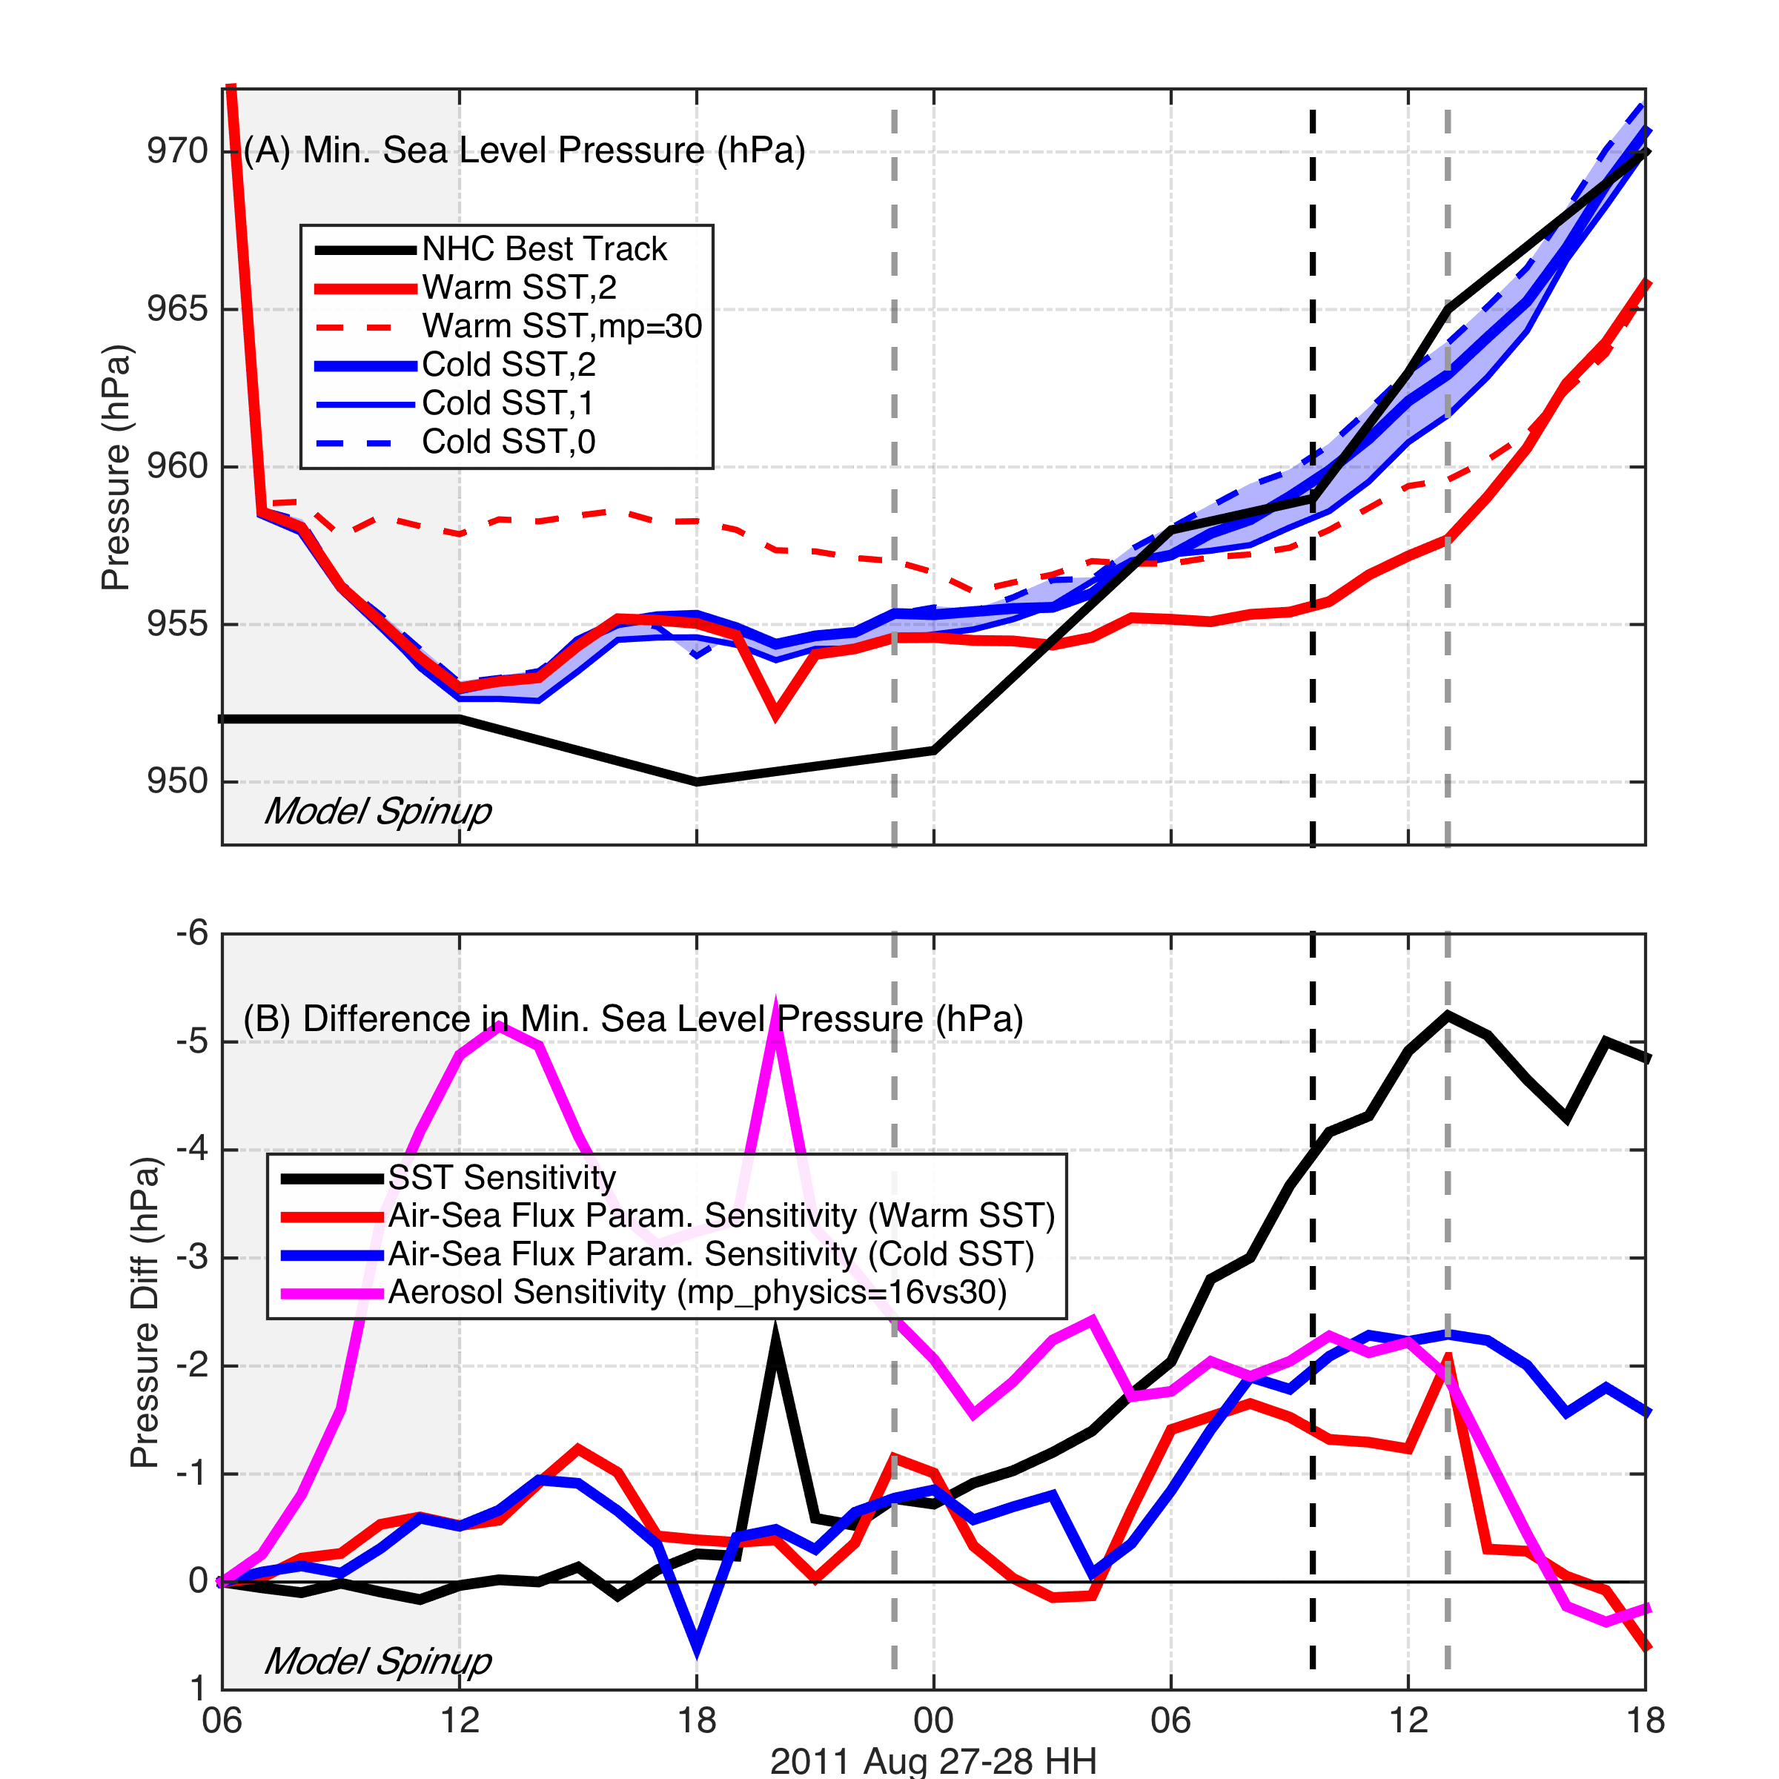
RR Fig. 1: (A) Minimum sea level pressure time series from the additional sensitivity to aerosols using WRF spectral bin microphysics (mp_physics=30) as shown in dashed red. Solid red is mp_physics=16 with warm SST, and blue thick solid, thin solid, and dashed are cold SST using isftcflx=2, 1, and 0, respectively. (B) Same as Figure 5 but with the additional sensitivity to aerosols shown in magenta.

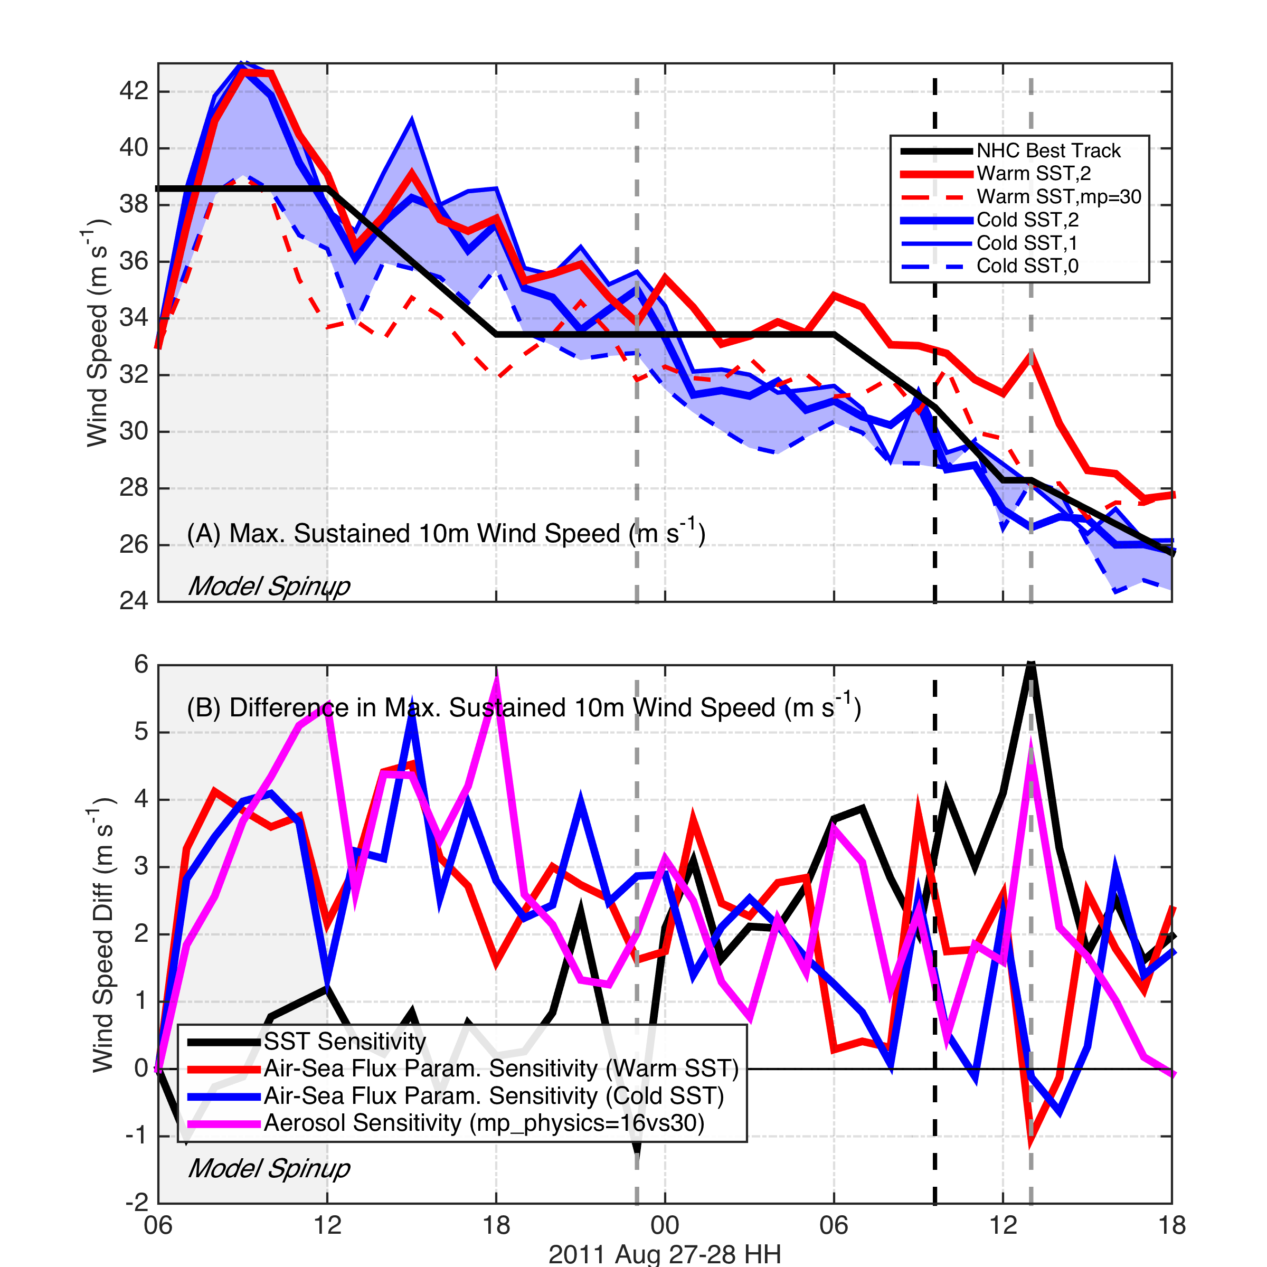
RR Fig. 2: Same as RR Fig. 1 but for maximum sustained 10m winds.

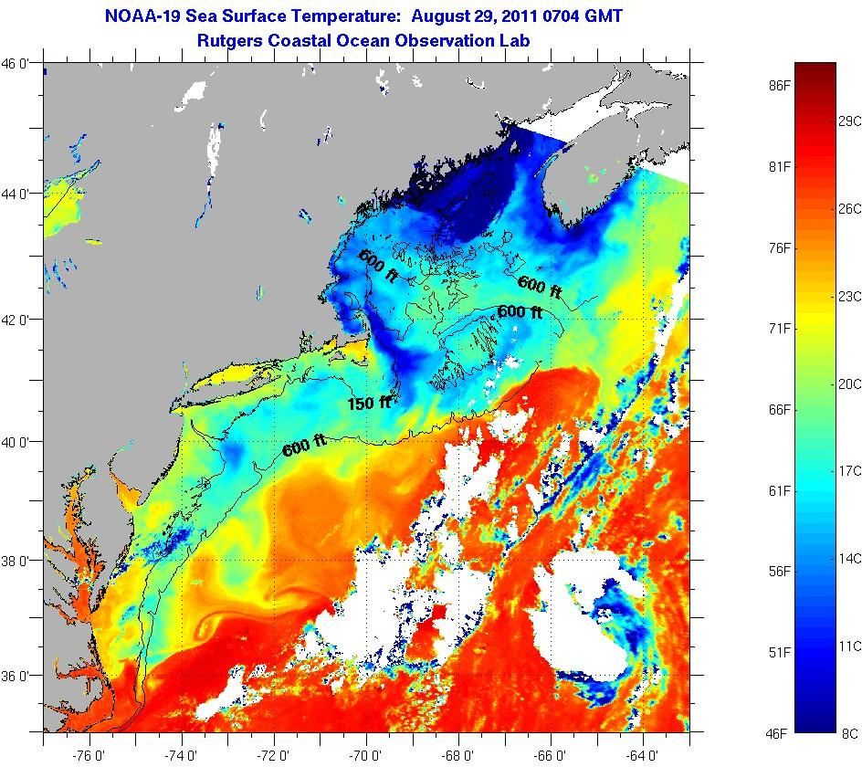
RR Fig. 3 Individual NOAA-18 AVHRR SST image from 0704 UTC on August 29, 2011, showing the very cold (blue) water over the Hudson Canyon immediately after the direct storm forcing and a patch of cloudy pixels offshore of the Delmarva Peninsula that was removed prior to compositing.
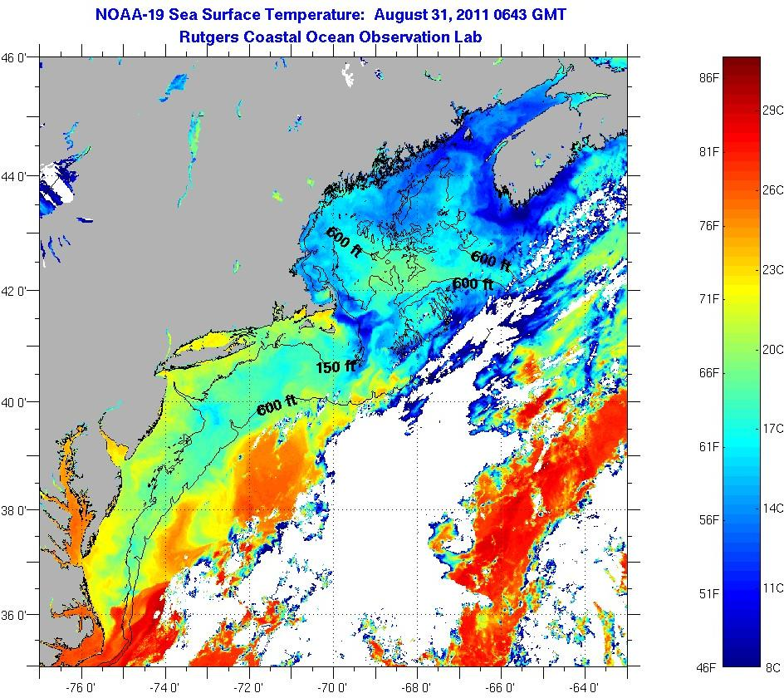
RR Fig. 4 Individual NOAA-18 AVHRR SST image from 0643 UTC on August 31, 2011, showing a slight warming over the Hudson Canyon and across the MAB 2 days into the inertial response. The patch of cloudiness is now gone offshore of the Delmarva Peninsula.

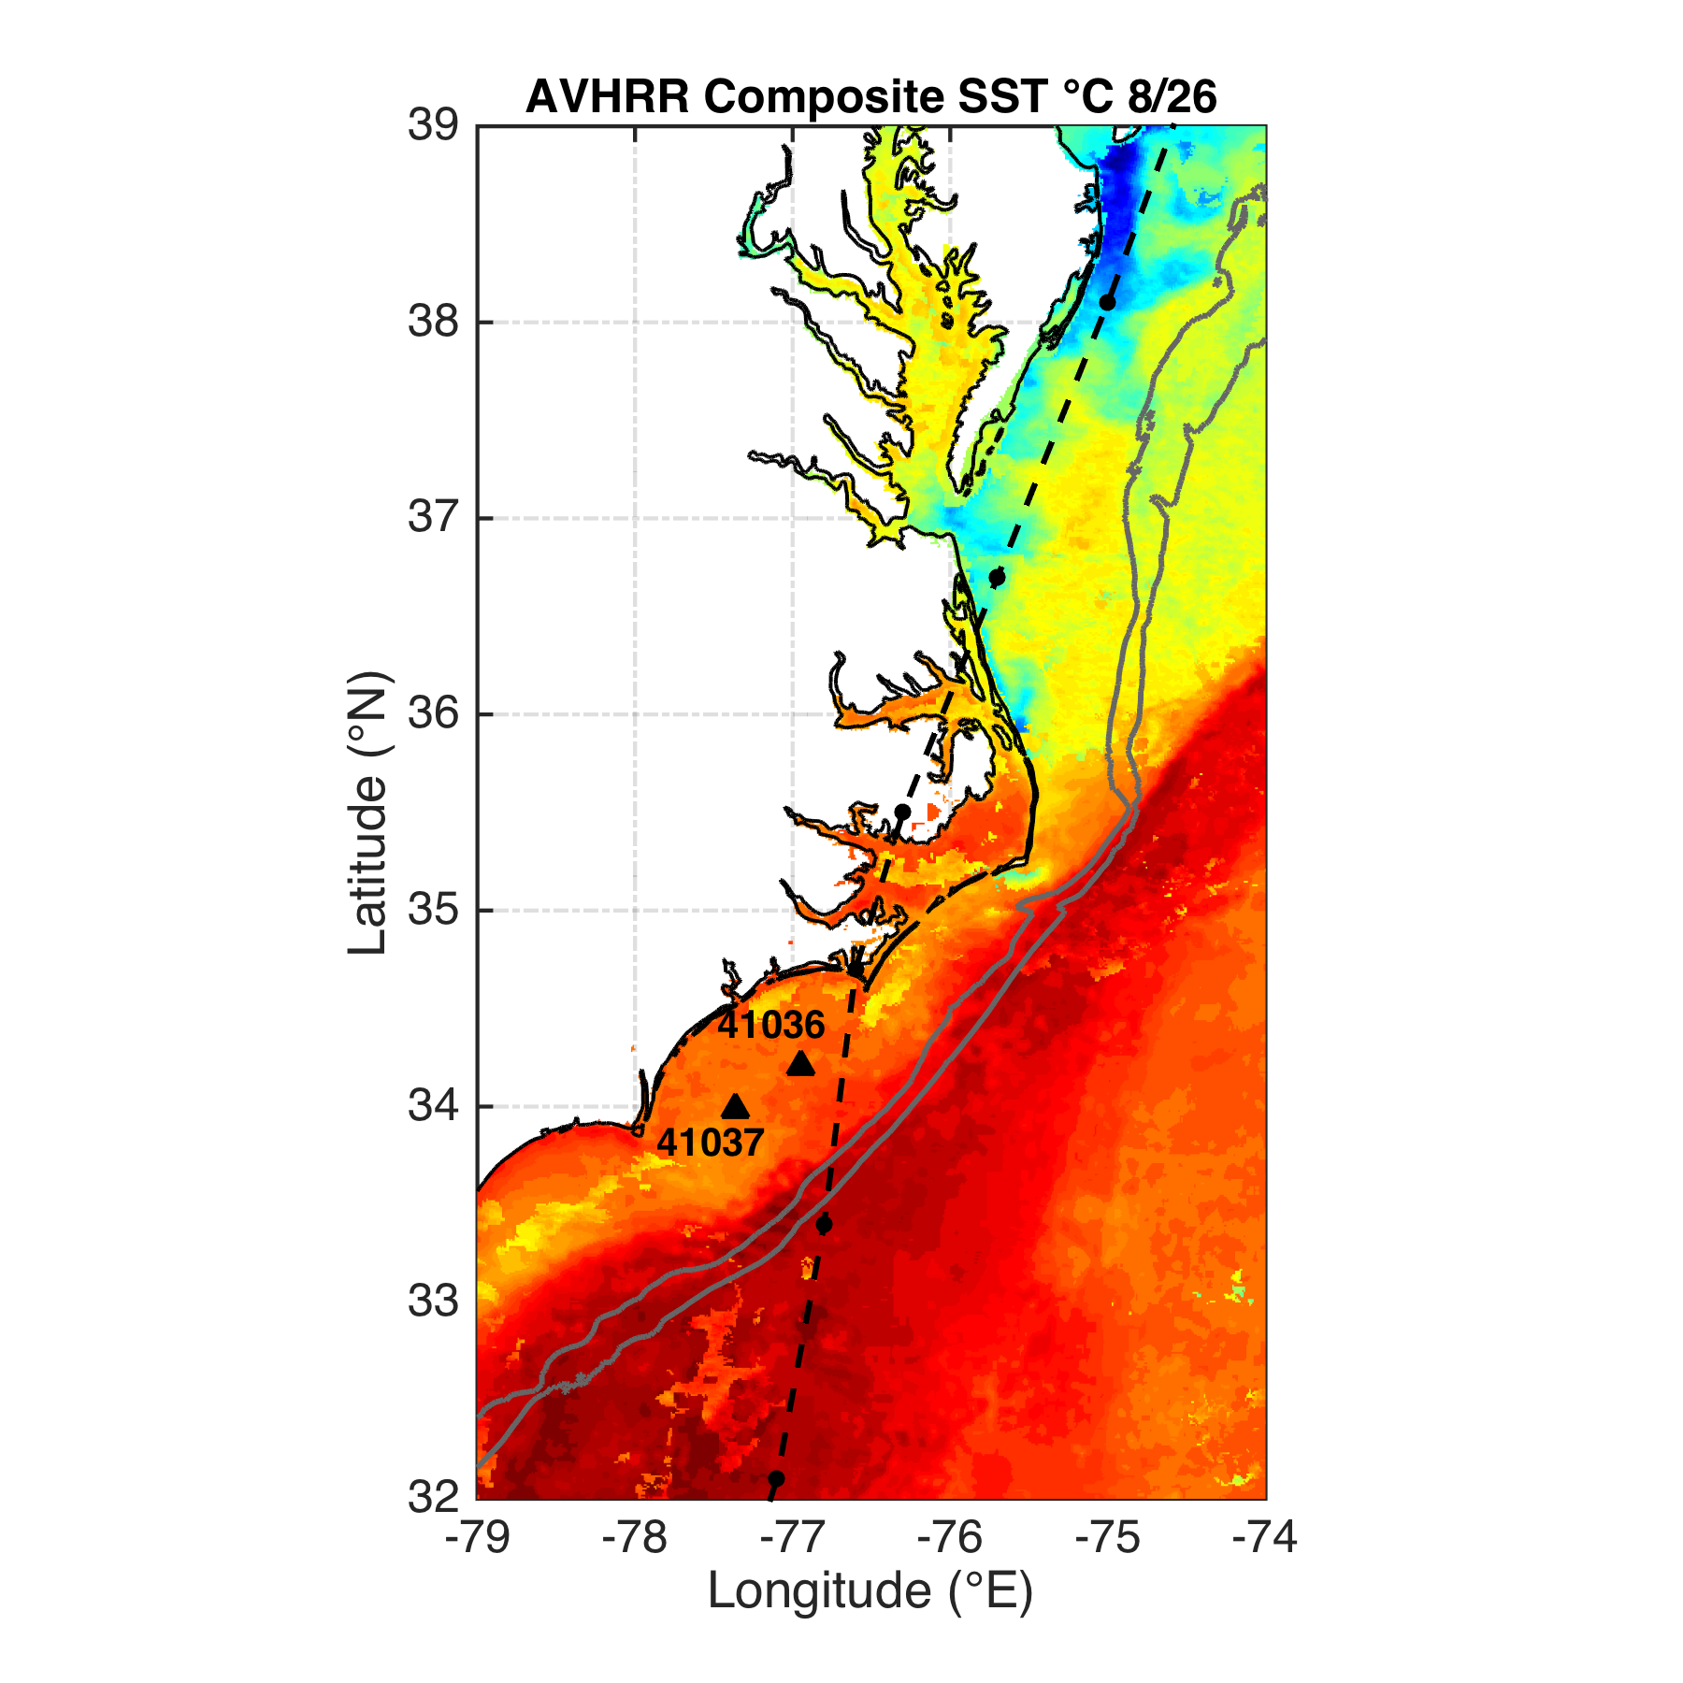
RR Fig. 5 Map of SST from the coldest pixel AVHRR composite on August 26, 2011, showing buoys 41036 and 41037 on the South Atlantic Bight Continental Shelf inshore of the Gulf Stream.

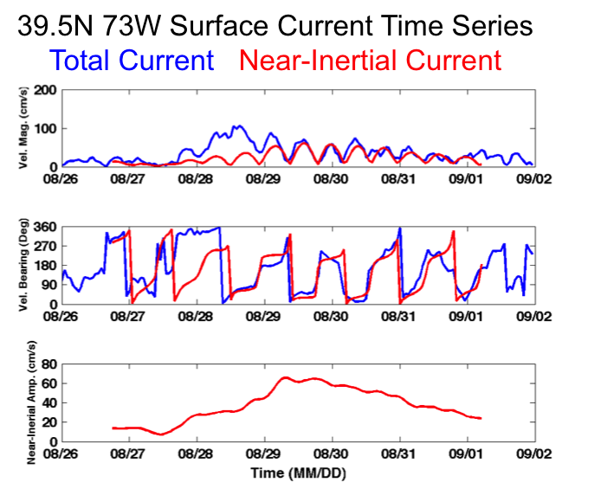
RR Fig. 6 High Frequency radar surface currents were extracted from a point near the glider location. Blue represents the total current, while red is the near-inertial (18 hour) band between 16 and 20 hours. Landfall time was on August 28 at 0935 UTC while the direct forcing dominated the signal and prior to the spin-up of the near-inertial energy.

