May Test QuickLook Report

Maritime Surveillance Microwave Radar

QuickLook Test Report for May 2003 Testing of the Maritime Surveillance Microwave Radar

15 July 2003

DRAFT



DoD Counterdrug Technology Development Program Office

Technology Implementation and Platforms
Naval Surface Warfare Center, Dahlgren Division
17320 Dahlgren Road
Dahlgren, VA 22448-5100
QuickLook Test Report

Maritime Surveillance Microwave Radar May 2003 Tests

QuickLook Test Report for May 2003 Testing of the Maritime Surveillance Microwave Radar

Prepared by:

/ 15 July 2003
Stephen G. Thomas Date
CDTDPO, Scientist

Approved by:

/ 15 July 2003
Mark J.Seastrand Date
CDTDPO, Technical Agent

Released by:

/ 15 July 2003
Bruce Corso Date

CDTDPO, Program Manager

Introduction

This report is intended to provide a “QuickLook” summary of recent CDTDPO sponsored MSMR maritime surveillance results obtained off the West coast of Puerto Rico. Tests were run in cooperation with US Customs and MSSC Corp., from 5/13/03-5/15/03 per CDTDPO document ST_MSMR Test Procedures5. Tracks are compared for ground truth (onboard GPS) and radar data obtained in real time at the times indicated. Relevant parameters are explained and defined below.

Definitions

Begin – Initial GPS time the test boat acquired the heading and/or speed of the intended route.
End – Final GPS time the test boat was traveling at the heading and/or speed of the intended route.
Available weather data – Wind speed provided in meters per second (m/s) and cardinal direction of origin as North (N), South (S), East-South-East (ESE), etc. Wave height provided in feet (ft.).
TTI – Time To Initiate. Time difference in hours:minutes:seconds (hh:mm:ss) between Begin (GPS) and establishment of the first radar track at the correct heading and/or speed. A positive Time To Initiate indicates a delay in the establishment of a radar track compared to ground truth.
HT – Holding Time. Percent of the total length (GPS time) of a track the radar maintains a single track.
DT – Drift Time. Time difference in hours:minutes:seconds (hh:mm:ss) between End (GPS) and the last radar recorded time of the single track associated with that route. A positive Drift Time indicates additional radar tracking time in excess of ground truth.
Tracking and stale radar track – It is possible for a single established radar track number (i.e. track T280) to be associated with 2 different GPS routes of the test boat. In this report this is termed a stale track. For example, radar track T280 may be associated with a test boat traveling inbound. The boat reaches its designated waypoint and turns (or momentarily stops) to proceed on to the outbound route in the procedures. The outbound radar track may also be designated by the tracker as T280. T280 would then be termed, for this report, a stale track. The alternate scenario would see T280 dropped by the tracker and a new track (track T281 for example) initiated for the outbound route. Drift Time in this example would only be calculated for the latter scenario. It would be the difference between the End (GPS) time of the target’s inbound route and the last recorded time of track T280 prior to initiation of T281. This is illustrated in Figure 1 below.

Figure 1. Illustration of Time To Initiate (TTI) and Drift Time (DT)

DT

TTI

GPS track
Radar track T280
1
2
2
3
3
1
New radar track
T281 after drift

TTI

TTI is the difference between the beginning of the inbound Begin (GPS) time (black arrow 1) and the time of initiation of the radar track T280 (red arrow 1). DT is the difference between the end of the GPS time on the inbound route (black arrow 2) and the time of the end of the radar track T280 (red arrow 2). Note that a new radar track T281 (red arrow 3) is initiated for the outbound route. In this case the TTI for the outbound route would be the difference between the beginning of the outbound Begin (GPS) time (black arrow 3) and the time of initiation of the radar track T281 (red arrow 3).

In addition to the tracking Time To Initiate and Drift Time, we also include detection range on each plot. For May Test 1 and May Test 2, the test boat remained within 10 nautical miles (nm) of the radar in the full coverage area. All distances from Radar to the waypoints are indicated in nautical miles inside parentheses beside each waypoint. For May Test 3B, the target vessel traveled beyond 10 nm out to 20 nm. The distance from Radar out to the last radar detection of the boat is indicated on these plots in addition to the waypoint information.

Radar Operating Parameters: Antenna height approx. 325 ft. above sea level
FMCW, horizontal polarization
1 KHz WRF at 13 MHz bandwidth
Frequency 9.443-9.473 GHz
Scan Rate 9.5 rev/min
Beamwidth 1.4 deg (H), 20 deg (V)
Peak/mean power 20W
Tracker Parameters: ???

May Test 1

Date of Test: May 13, 2003
Time: 07:55:49 to 10:36:12 EST

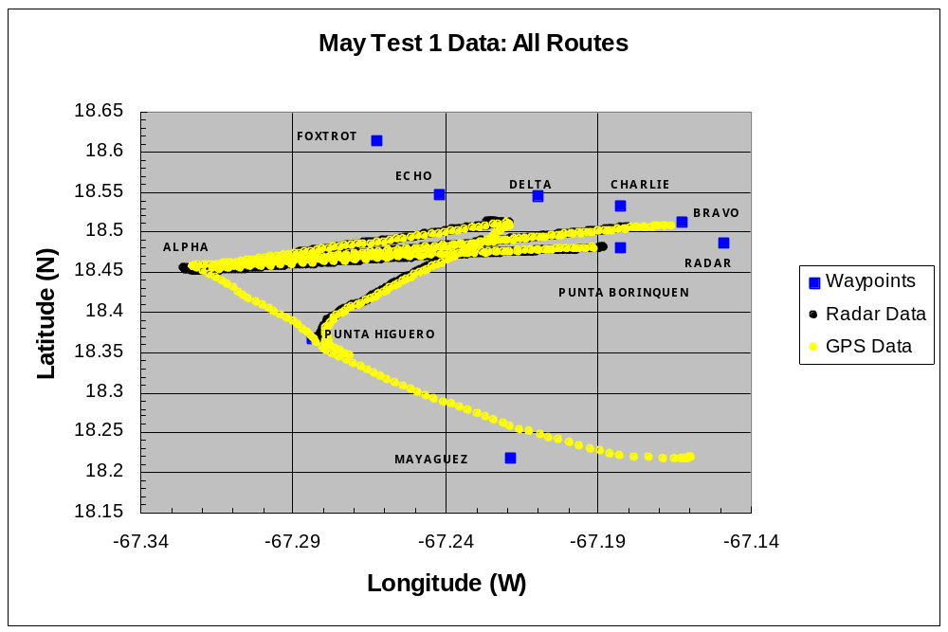
(10)
(10.5)
(16.5)
(10)
(6.4)
(5)
(3.4)
(1.8)
(2)

Route 1 Parameters

Begin: 07:55:49 EST
End: 08:24:49 EST
Sea conditions as reported by crew: N/A
Available weather data: winds ESE 2.6-4.6 m/s, waves 2-4 ft., significant wave height 4 ft.
TTI: 00:09:47
HT:
DT: 00:05:12

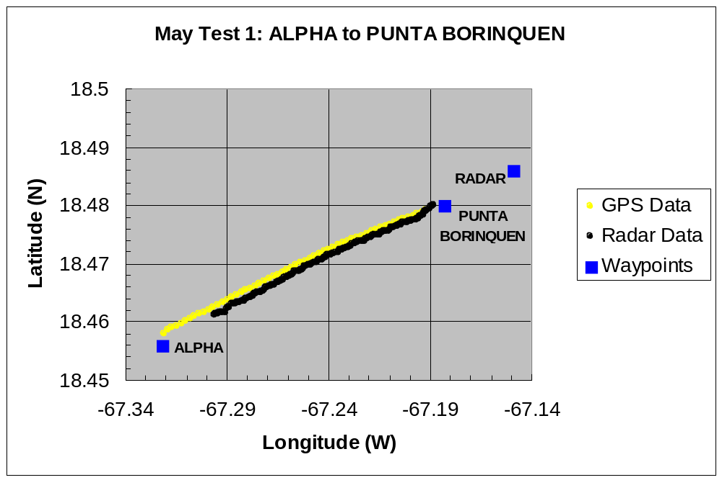
(10)
(2)

Route 2 Parameters

Begin: 08:25:19 EST
End: 08:43:41 EST
Sea conditions as reported by crew: N/A
Available weather data: winds ESE 2.6-4.6 m/s, waves 2-4 ft. , significant wave height 4 ft.
TTI: 00:05:49
HT:
DT: 00:05:28

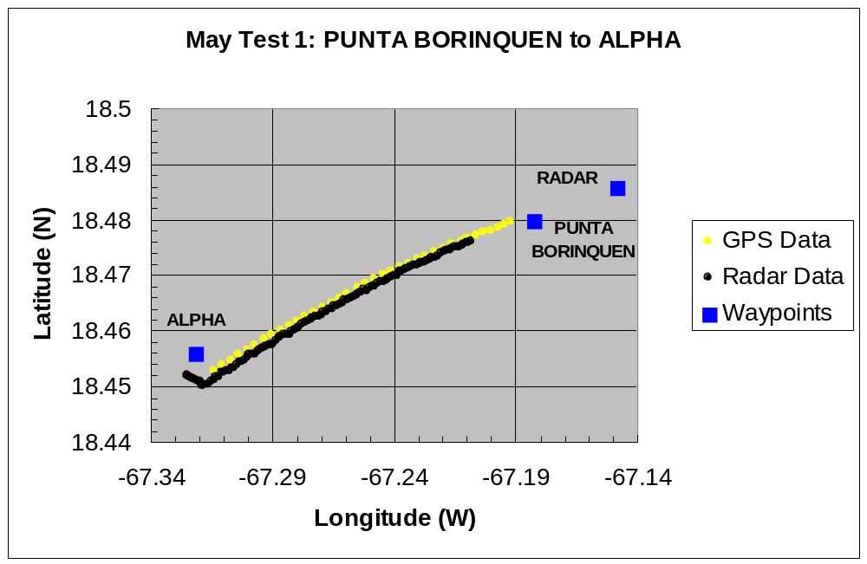
(2)
(10)

Route 3 Parameters

Begin: 08:44:11 EST
End: 09:19:17 EST
Sea conditions as reported by crew: N/A
Available weather data: winds ESE 4.6-6.6 m/s, seas 2-4 ft., significant wave height 4 ft.
TTI: 00:05:55
HT:
DT: 00:01:09

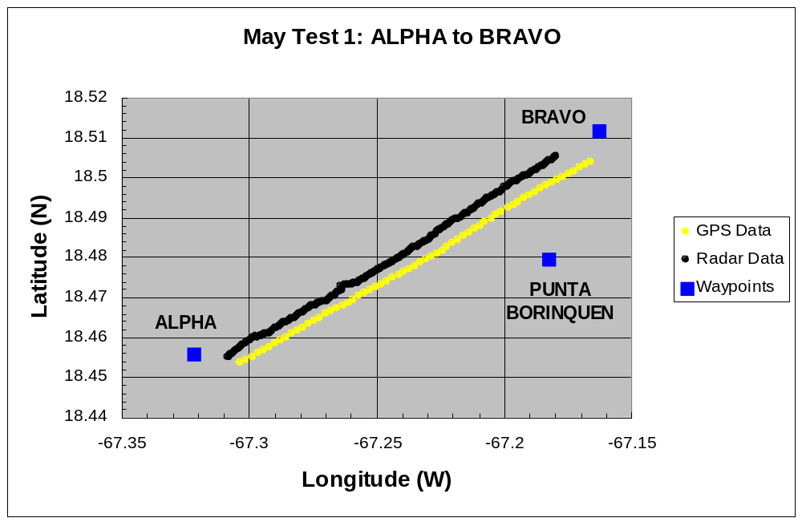
(10)
(2)
(1.8)

Route 4 Parameters

Begin: 09:19:47 EST
End: 09:45:16 EST
Sea conditions as reported by crew: N/A
Available weather data: winds E 4.6-6.6 m/s, seas 2-4 ft., significant wave height 5 ft.
TTI: 00:10:10
HT:
DT: 00:05:25

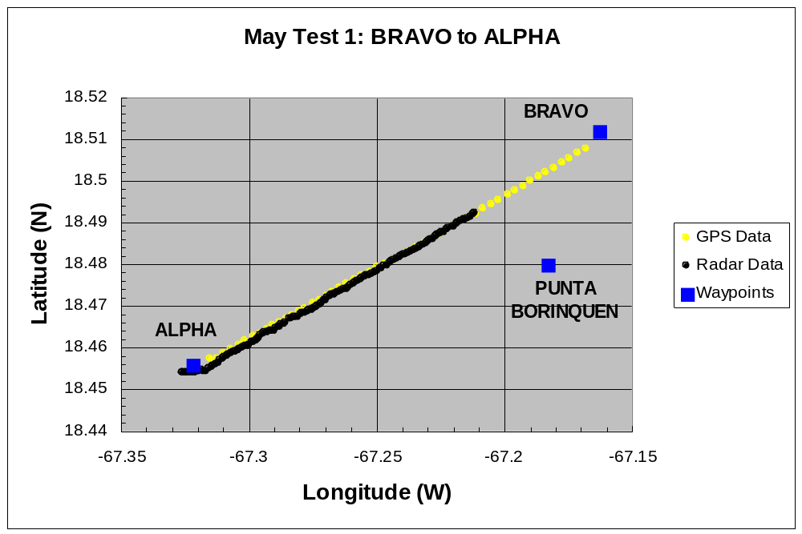
(2)
(10)
(1.8)

Route 5 Parameters

Begin: 09:46:20 EST
End: 10:09:43 EST
Sea conditions as reported by crew: waves 4-6 ft., breakers, had to call off test and return to base before reaching CHARLIE
Available weather data: winds E 6.7 m/s, seas 3-5 ft., significant wave height 5 ft.
TTI: 00:11:18
HT:
DT: 00:08:44

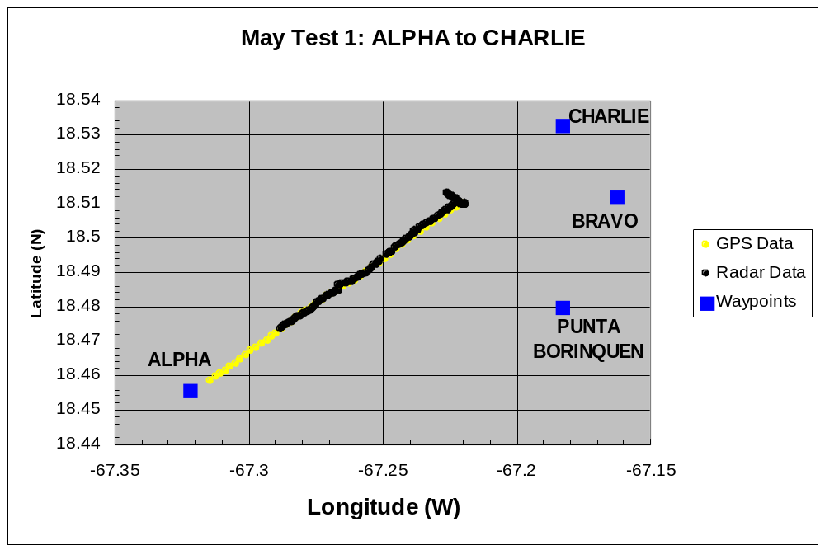
(10)
(2)
(1.8)
(3.4)

Route 6 Parameters

Begin: 10:10:16 EST
End: 10:36:12 EST
Sea conditions as reported by crew: waves 4-6 ft., breakers, had to call off test and return to base before reaching CHARLIE
Available weather data: winds E 7.5 m/s, seas 3-5 ft., significant wave height 5 ft.
TTI: 00:08:19
HT:
DT: N/A; out of range

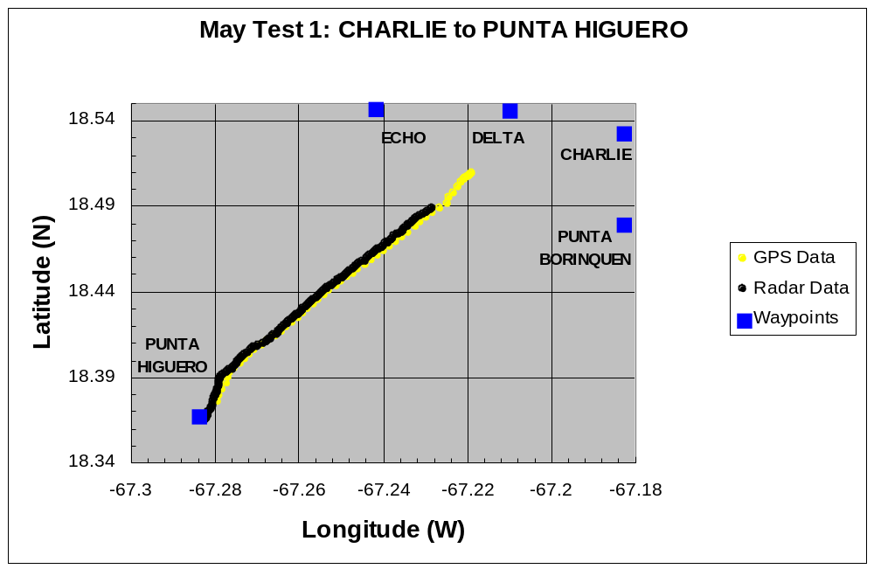
(10.5)
(6.4)
(5)
(3.4)
(2)

May Test 2

Date of Test: May 14, 2003
Time: 07:04:42 to 09:04:11 EST

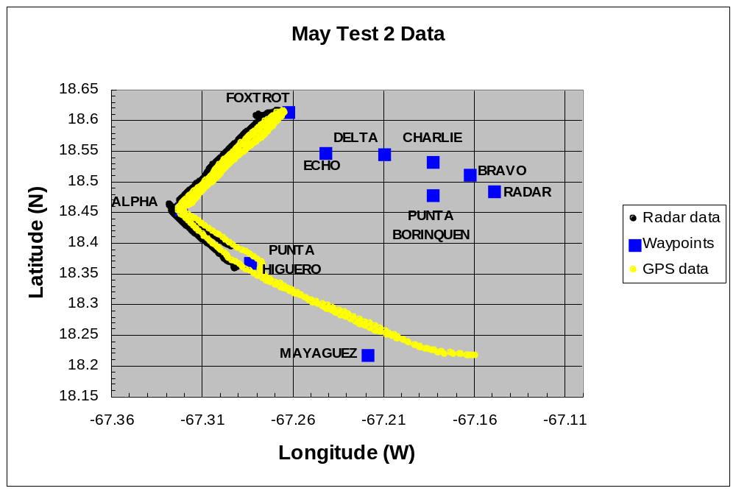
(10.5)
(6.4)
(5)
(3.4)
(2)
(10)
(1.8)
(16.5)
(10)

Route 1 Parameters

Begin: 07:04:42 EST
End: 07:34:56 EST
Sea conditions as reported by crew: seas 3-5 ft., “rollers”
Available weather data: winds NE 2.6 m/s, seas 2-4 ft.
TTI: 00:12:57
HT:
DT: 00:08:37

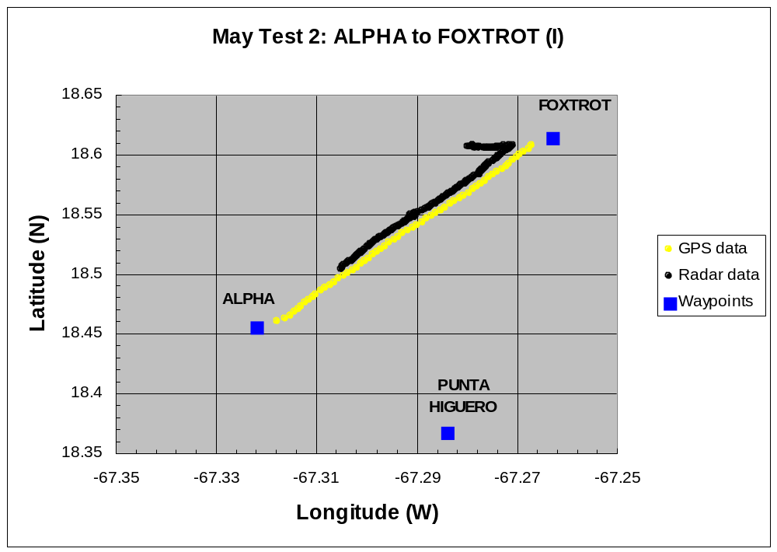
(10)
(10)
(10.5)

Route 2 Parameters

Begin: 07:35:26 EST
End: 08:05:38 EST
Sea conditions as reported by crew: seas 3-5 ft., “rollers”
Available weather data: winds ESE 2.6 m/s
TTI: 00:08:15
HT:
DT: 00:01:15

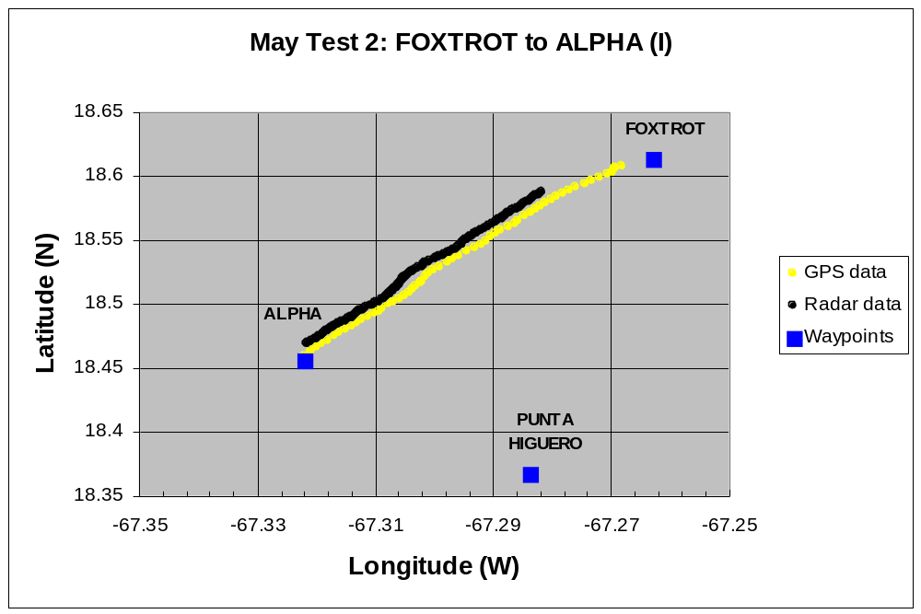
(10)
(10)
(10.5)

Route 3 Parameters

Begin: 08:06:08 EST
End: 08:34:11 EST
Sea conditions as reported by crew: Seas 3-5 ft., crests closer together, “breakers”
Available weather data: winds ESE 2.6 m/s
TTI: 00:09:21
HT:
DT: N/A; stale radar track

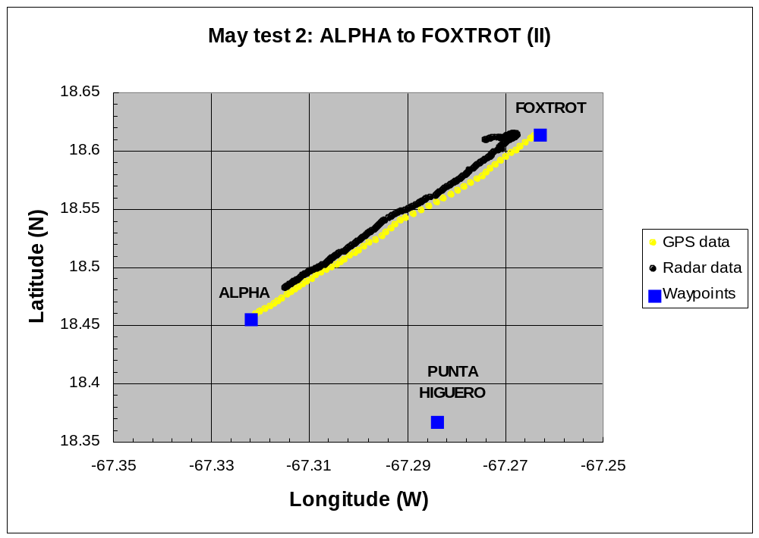
(10)
(10)
(10.5)

Route 4 Parameters

Begin: 08:34:41 EST
End: 09:04:11 EST
Sea conditions as reported by crew: seas 3-5 ft., “rollers”, some “breakers”
Available weather data: winds ESE 2.6 m/s
TTI: N/A; stale radar track
HT:
DT: N/A; stale radar track
Route 4 ALPHA to Home TTI: N/A; stale radar track
Route 4 ALPHA to Home DT: N/A; out of range

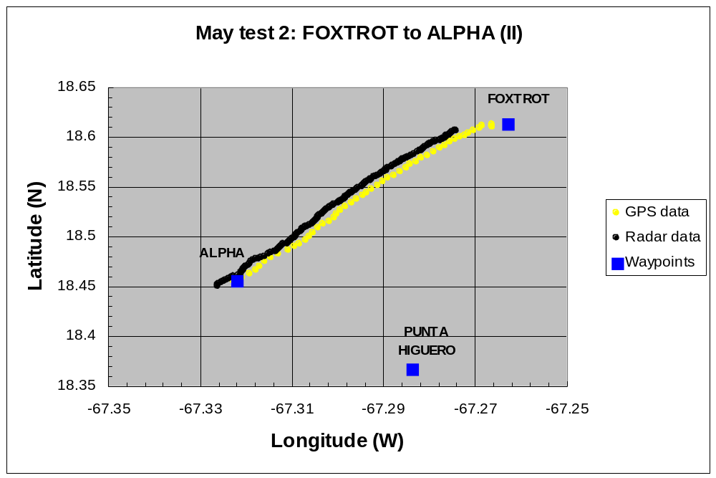
(10)
(10)
(10.5)

May Test 3B

Date of Test: May 15, 2003
Time: 06:18:12 to 09:38:17 EST

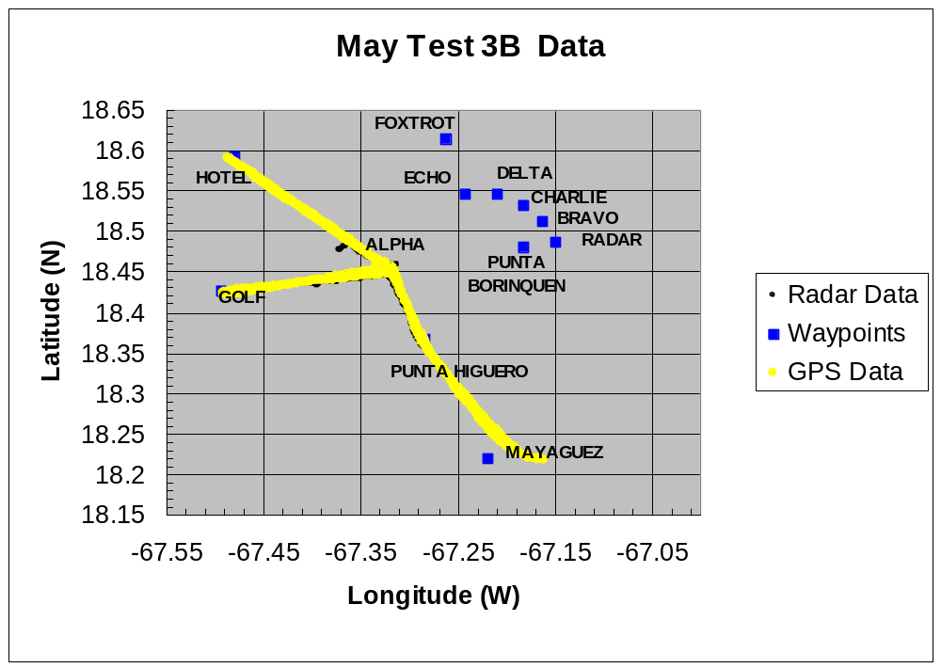
(10)
(10)
(10.5)
(16.5)
(1.8)
(2)
(3.4)
(6.4)
(5)
(20)
(20)

Route 1 Parameters

Begin: 06:56:57 EST
End: 07:26:27 EST
Sea conditions as reported by crew: seas 3-4 ft., “rollers”
Available weather data: winds N .9 m/s
TTI: N/A; stale radar track
HT:
DT: N/A; out of range

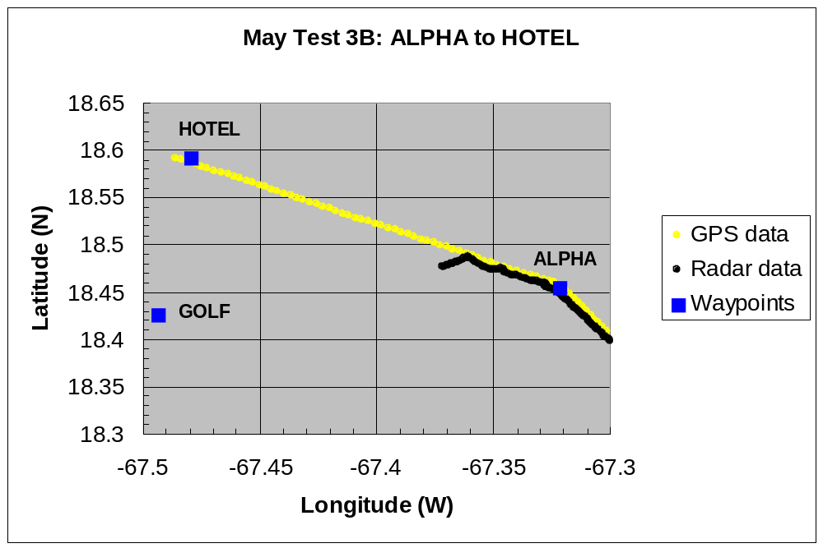
(12.5)
(11.9)
(20)
(20)
(10)

Route 2 Parameters

Begin: 07:26:57 EST
End: 08:03:36 EST
Sea conditions as reported by crew: seas 3-4 ft., “rollers”
Available weather data: winds NE 1.8 m/s
TTI: N/A; out of range
HT:
DT: N/A; stale radar track

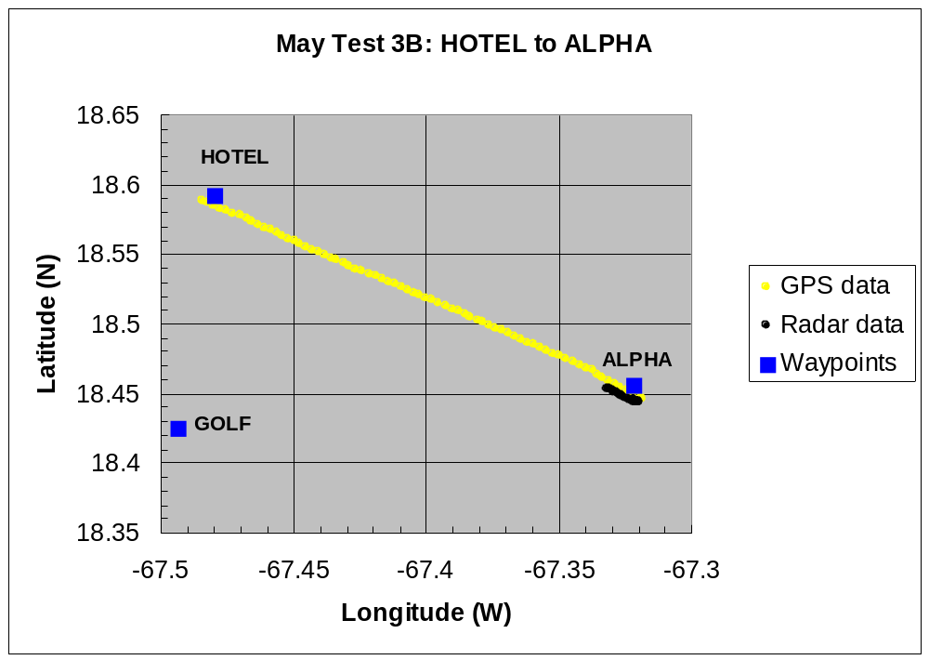
(10.4)
(20)
(20)
(10)

Route 3 Parameters

Begin: 08:09:43 EST
End: 08:34:09 EST
Sea conditions as reported by crew: seas 3-5 ft., “rollers”, some “breakers”
Available weather data: winds ESE 4.6 m/s
TTI: N/A; stale radar track
HT:
DT: N/A; out of range

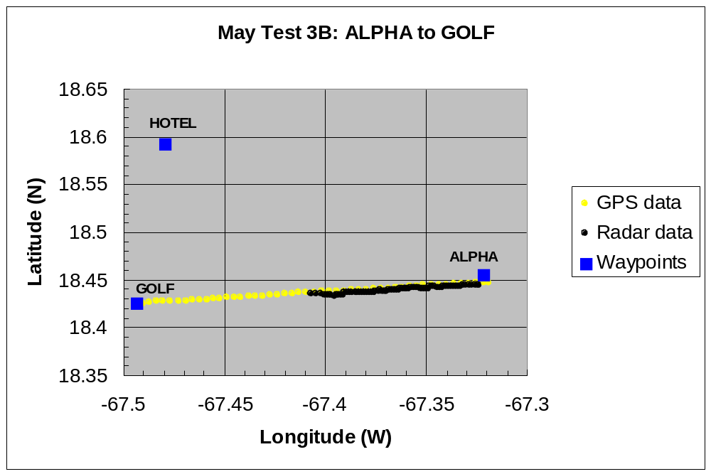
(14.6)
(20)
(20)
(10)

Route 4 Parameters

Begin: 08:34:39 EST
End: 08:59:38 EST
Sea conditions as reported by crew: seas 3-5 ft., mostly “breakers"
Available weather data: winds ESE 5.1 m/s
TTI: N/A; out of range
HT:
DT: 00:01:51
Rout 4 ALPHA to Home TTI: 00:10:03
Route 4 ALPHA to Home DT: N/A; out of range

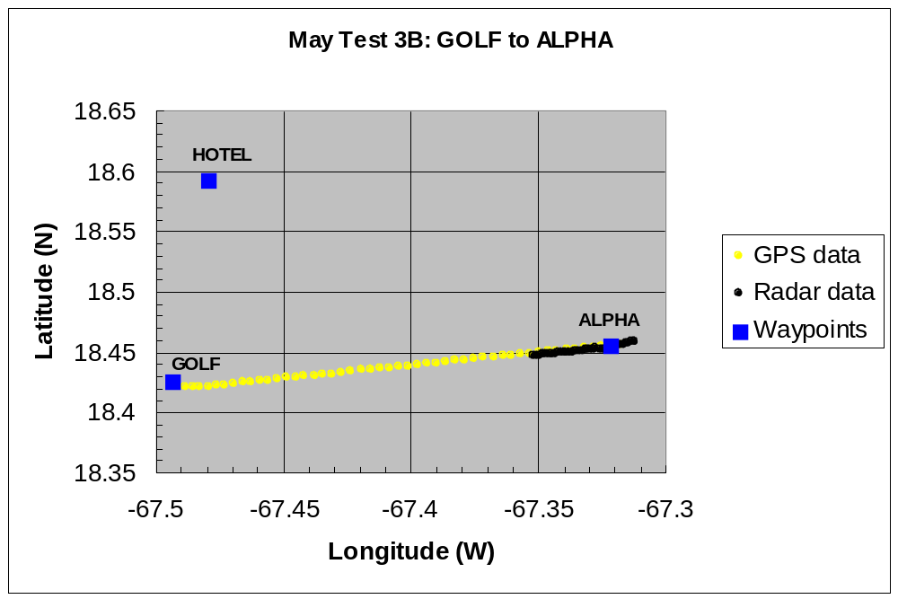
(11.5)
(20)
(20)
(10)

